DBsono F33 Bluetooth Speaker FCC RF Test Report

1. Basic Report Information
Item | Information
Report name | RF TEST REPORT
Report number | LGT25F074RF01
FCC ID | 2BOBD-F33
Issuing organization | Shenzhen LGT Test Service Co., Ltd.
Sample receipt date | Jun. 10, 2025
Test dates | Jun. 10, 2025 ~ Jun. 17, 2025
Issue date | Jun. 17, 2025
Version and revision | Rev. 00；Jun. 17, 2025；Initial Issue
Overall test result | PASS
Conditions for report validity | The report is valid only when it bears both the signatures and the dedicated seal.
Reproduction restrictions | This report may not be reproduced in part without the laboratory's written approval; it may only be reproduced in full.
Scope of results | The results in this report apply only to the tested samples.

2. Product and Applicant
Item | Information
Product name | Bluetooth Speaker
Trademark | dbsono
Main model | F33
Series model | DB F33
Model differences | All models are identical except the Bluetooth name and model number, therefore the test performed on the model F33
Sample condition | Normal
Operating frequency | 2402–2480 MHz
Modulation methods | GFSK (1 Mbps)、π/4-DQPSK (2 Mbps)、8DPSK (3 Mbps)
Antenna | PCB；-0.58 dBi
Rated input | DC 5 V 1 A
Battery | 1200 mAh; rated voltage 3.7 V
Hardware version | V1.1
Software version | 31E4-2029536D
Applicant | shenzhenshihongyineryuekejiyouxiangongsi
Applicant's address | No. 208-28, Longhua Jianshe Road, Jinglong Community, Longhua Street, Longhua District, Shenzhen, 518000, China
Manufacturer | Dongguan Jin wen hua digital technology Co.,LTD
Manufacturer's address | NO.1 hua Da Road,Long Bei Ling Village,Tangxia Town,Dongguan City,Guangdong,china

3. Testing Organization and Signatures
Item | Information
Organization name | Shenzhen LGT Test Service Co., Ltd.
Organization address | Room 205, Building 13, Zone B, Zhenxiong Industrial Park, No.177, Renmin West Road, Jinsha, Kengzi Street, Pingshan District, Shenzhen, Guangdong, China
A2LA Certificate No. | 6727.01
FCC Registration No. | 746540
CAB ID | CN0136
Telephone | 0755-89668180
Email | lgt@lgt-cert.com
Website | www.lgt-cert.com
Prepared by | Zane Shan；Engineer
Approved by | Vita Li；Technical Director
Signatures and seal | Signatures of the preparer and approver; dedicated seal of Shenzhen LGT Test Service Co., Ltd.

4. Applicable Standards and Test Conclusions
Standard or basis | Test result
FCC Part 15.247, Subpart C；ANSI C63.10-2013 | PASS
KDB 558074 D01 15.247 Meas Guidance v05r02 | Basis of test procedures listed in the report

Standard clause | Test item | Assessment | Remarks
15.207 | Conducted Emission | PASS | --
15.247(a)(1) | Hopping Channel Separation | PASS | --
15.247(a)(1)&(b)(1) | Output Power | PASS | --
15.209 | Radiated Spurious Emission | PASS | --
15.247(d) | Conducted Spurious & Band Edge Emission | PASS | --
15.247(a)(1)(iii) | Number of Hopping Frequency | PASS | --
15.247(a)(1)(iii) | Dwell Time | PASS | --
15.247(a)(1) | Bandwidth | PASS | --
15.205 | Restricted bands of operation | PASS | --
Part 15.247(d)/part 15.209(a) | Band Edge Emission | PASS | --
15.203 | Antenna Requirement | PASS | --

5. Summary of Test Results

5.1. Test Basis and Item Assessments
Test basis: FCC Part 15.247, Subpart C; KDB 558074 D01 15.247 Meas Guidance v05r02. All testing was conducted according to ANSI C63.10-2013.
Standard clause | Test item | Assessment | Remarks
15.207 | Conducted Emission | PASS | --
15.247(a)(1) | Hopping Channel Separation | PASS | --
15.247(a)(1)&(b)(1) | Output Power | PASS | --
15.209 | Radiated Spurious Emission | PASS | --
15.247(d) | Conducted Spurious & Band Edge Emission | PASS | --
15.247(a)(1)(iii) | Number of Hopping Frequency | PASS | --
15.247(a)(1)(iii) | Dwell Time | PASS | --
15.247(a)(1) | Bandwidth | PASS | --
15.205 | Restricted bands of operation | PASS | --
Part 15.247(d)/part 15.209(a) | Band Edge Emission | PASS | --
15.203 | Antenna Requirement | PASS | --
N/A indicates that the test is not applicable; “--” is the remarks value in the results summary table.

5.2. Testing organization
Item | Information
Organization name | Shenzhen LGT Test Service Co., Ltd.
Address | Room 205, Building 13, Zone B, Zhenxiong Industrial Park, No.177, Renmin West Road, Jinsha, Kengzi Street, Pingshan District, Shenzhen, Guangdong, China
A2LA certificate number | 6727.01
FCC registration number | 746540
CAB ID | CN0136

5.3. Measurement Uncertainty
Measurement results are expressed as y ± U. Expanded uncertainty U is the standard uncertainty multiplied by a coverage factor of k=2, corresponding to a confidence level of approximately 95%. Measurement uncertainty is not included in the test results.
No. | Measurement item | Uncertainty
1 | Occupied Channel Bandwidth | ±0.46%
2 | RF Output Power, Conducted | ±0.71dB
3 | Power Spectral Density, Conducted | ±1.57dB
4 | Unwanted Emission, Conducted | ±0.63dB
5 | Conducted emission | ±2.80dB
6 | All Emissions, Radiated (0.009-30MHz) | ±2.16dB
7 | All Emissions, Radiated (30MHz-1GHz) | ±4.61dB
8 | All Emissions, Radiated (1GHz-18GHz) | ±5.49dB
9 | Temperature | ±0.5°C
10 | Humidity | ±2%
11 | Duty Cycle | ±2.3%

6. Product and Test Configuration

6.1. Equipment Under Test Specifications
Item | Information
Product / trademark | Bluetooth Speaker / dbsono
Test model / series model | F33 / DB F33
Model differences | All models are identical except for the Bluetooth name and model number; F33 was used for testing.
Bluetooth frequency | 2402–2480 MHz
Modulation and data rate | GFSK（1 Mbps）；π/4-DQPSK（2 Mbps）；8DPSK（3 Mbps）
Antenna type / gain | PCB / -0.58 dBi
Rated input | DC 5 V 1 A
Battery capacity / rated voltage | 1200 mAh / 3.7 V
Hardware version | V1.1
Software version | 31E4-2029536D
I/O ports and detailed functions | See the manufacturer's specifications or user manual.
Antenna information is provided by the manufacturer and applies only to the tested samples identified in the report; the customer is responsible for issues such as test result accuracy arising from incorrect antenna information.

6.2. Bluetooth Channels and Frequencies
Channel | Frequency MHz | Channel | Frequency MHz | Channel | Frequency MHz
00 | 2402 | 27 | 2429 | 54 | 2456
01 | 2403 | 28 | 2430 | 55 | 2457
02 | 2404 | 29 | 2431 | 56 | 2458
03 | 2405 | 30 | 2432 | 57 | 2459
04 | 2406 | 31 | 2433 | 58 | 2460
05 | 2407 | 32 | 2434 | 59 | 2461
06 | 2408 | 33 | 2435 | 60 | 2462
07 | 2409 | 34 | 2436 | 61 | 2463
08 | 2410 | 35 | 2437 | 62 | 2464
09 | 2411 | 36 | 2438 | 63 | 2465
10 | 2412 | 37 | 2439 | 64 | 2466
11 | 2413 | 38 | 2440 | 65 | 2467
12 | 2414 | 39 | 2441 | 66 | 2468
13 | 2415 | 40 | 2442 | 67 | 2469
14 | 2416 | 41 | 2443 | 68 | 2470
15 | 2417 | 42 | 2444 | 69 | 2471
16 | 2418 | 43 | 2445 | 70 | 2472
17 | 2419 | 44 | 2446 | 71 | 2473
18 | 2420 | 45 | 2447 | 72 | 2474
19 | 2421 | 46 | 2448 | 73 | 2475
20 | 2422 | 47 | 2449 | 74 | 2476
21 | 2423 | 48 | 2450 | 75 | 2477
22 | 2424 | 49 | 2451 | 76 | 2478
23 | 2425 | 50 | 2452 | 77 | 2479
24 | 2426 | 51 | 2453 | 78 | 2480
25 | 2427 | 52 | 2454
26 | 2428 | 53 | 2455

6.3. Test Modes and Power Supply Conditions
Operating modes and test configurations that may affect electromagnetic emission levels are individually prescanned and evaluated to obtain the maximum EMI emission characteristics.
Mode | Operating configuration | Modulation / status
Mode 1 | TX CH00（2402 MHz） | DH5/GFSK
Mode 2 | TX CH39（2441 MHz） | DH5/GFSK
Mode 3 | TX CH78（2480 MHz） | DH5/GFSK
Mode 4 | TX CH00（2402 MHz） | 2DH5/π/4-DQPSK
Mode 5 | TX CH39（2441 MHz） | 2DH5/π/4-DQPSK
Mode 6 | TX CH78（2480 MHz） | 2DH5/π/4-DQPSK
Mode 7 | TX CH00（2402 MHz） | 3DH5/8DPSK
Mode 8 | TX CH39（2441 MHz） | 3DH5/8DPSK
Mode 9 | TX CH78（2480 MHz） | 3DH5/8DPSK
Mode 10 | Hopping | DH5/GFSK
Mode 11 | Hopping | 2DH5/π/4-DQPSK
Mode 12 | Hopping | 3DH5/8DPSK
Mode 13 | AC Conducted Emission | Keeping BT TX
Measurements cover all transmitter bit rates, and the worst-case data are recorded.
Testing covers the U.S. supply voltages and frequencies supported by the equipment: 120 V, 240 V, and 50/60 Hz; the report uses the worst-case results at 120 V / 60 Hz. The battery was fully charged for radiated and RF conducted testing.

6.4. Frequency-Hopping System Requirements and Operation

6.4.1. Standard Requirements
FCC Part 15.247(a)(1): The system selects channels from a pseudorandomly ordered frequency list at the hopping rate; each frequency should be used equally on average by each transmitter. The receiver input bandwidth should match the hopping channel bandwidth of the corresponding transmitter, and the receiver should change frequencies in synchronization with the transmitted signal.
Not all available channels are required for each transmission, but the transmitter-receiver system must meet the corresponding provisions under continuous data flow conditions. Systems using short-burst transmissions must still meet the definition of a frequency-hopping system and distribute transmissions over the specified minimum number of channels.
A system may independently identify other users in the band and adjust its hopping set to avoid occupied channels; other coordination of frequency-hopping systems to avoid simultaneous occupation of a single hopping frequency by multiple transmitters is not permitted.

6.4.2. Pseudorandom Sequence
Item | Information
Number of shift register stages | 9
Feedback method | The outputs of stages 5 and 9 are added modulo 2, and the result is fed back to the input of stage 1.
Initial state | 9 consecutive 1s; the sequence begins with the first of these consecutive 1s.
Sequence length | 2⁹−1 = 511 bits
Longest run of consecutive 0s | 8 (non-inverted signal)
Example hopping sequence | 0、2、4、6、62、64、78、1、73、75、77
Pseudorandom Sequence Generator and Hopping Sequence Diagram
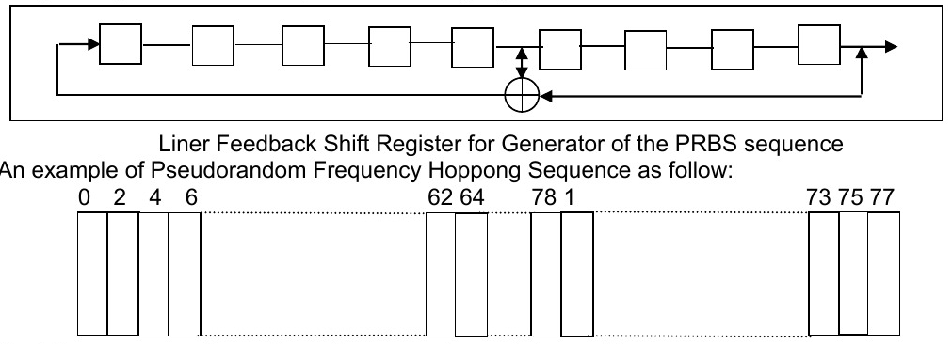
The upper part of the diagram shows a nine-stage linear feedback shift register and its feedback path; the lower part shows the hopping frequency sequence. Each frequency is used equally on average by each transmitter. The receiver bandwidth matches the transmitter channel bandwidth, and frequency changes are synchronized with the transmitted signal.

6.4.3. Bluetooth Frequency Hopping and Adaptive Frequency Hopping
Item | Information
Operating band | 2400–2483.5 MHz
Channel configuration | Up to 79 bands, each 1 MHz, with center frequencies of 2402–2480 MHz.
Hopping rate | 1600 changes per second.
Sequence and phase | The hopping sequence is determined by the master device's address; the hopping frequency at a particular time is determined by the master's internal clock.
Piconet synchronization | Bluetooth devices in the same piconet synchronize to the same hopping channel; slave devices must know the master's address and synchronize to its clock.
Frequency-hopping spread spectrum divides transmitted data into segments sent in different frequency bands; the report describes rapid frequency switching as a means of protecting data security.
Adaptive frequency hopping (AFH) identifies “bad” channels with mutual interference, shares bad-channel information within the piconet, and switches to other available “good” channels to avoid interference areas without affecting the bandwidth used.
The equipment was tested with a Bluetooth system receiver to confirm that hopping synchronization was maintained; the report concludes that it meets FCC Part 15.247 requirements.

6.5. Test Software and Power Settings
Item | Information
Test software version | FCC_assist_AC696_1.0.2.2
Test program | Bluetooth
Mode / modulation rate |  | Power setting
1M |  | 10
2M |  | 10
3M |  | 10
Testing uses customer-provided channel and power control software to control the operating channel and output power. The selected RF output power corresponds to the customer's intended settings and will be fixed in the final product's FHSS power-parameter firmware.

6.6. Support Equipment and Accessories
The equipment under test is configured as a standalone unit with the necessary accessories or support equipment to form a representative test configuration.
Equipment | Manufacturer | Model | Serial number | Rated specifications
Laptop | Lenovo | HKF-16 | N/A | N/A
Adapter | Tenpao | S005CAU0500100 | N/A | Input: 100–240 V ~ 50/60 Hz 0.2 A  ; Output: 5 V, 1 A
Lengths of detachable I/O cables should be recorded in cm in the Length column. “YES” indicates a ferrite core; “NO” indicates no ferrite core.

6.7. Test Equipment and Calibration Information

6.7.1. Conducted Emission Equipment
Equipment | Manufacturer | Model | Serial number | Calibration date | Valid until
EMI Test Receiver | R&S | ESU8 | 100372 | 2025.03.06 | 2026.03.05
LISN | COM-POWER | LI-115 | 02032 | 2025.03.05 | 2026.03.04
LISN | SCHWARZBECK | NNLK 8122 | 00160 | 2025.03.05 | 2026.03.04
Transient Limiter | CYBERTEK | EM5010A | E2250100049 | 2025.03.05 | 2026.03.04
Coaxial cables (9kHz-30MHz) | Juncoax | JMR600-NMNM-2M | N.A | 2025.03.06 | 2026.03.05
Temperature & Humidity | JINGCHUANG | BT-3 | N.A | 2025.03.10 | 2026.03.09
Test software: EMC-I_V1.4.0.3_SKET

6.7.2. Radiated Emission Equipment
Equipment | Manufacturer | Model | Serial number | Calibration date | Valid until
EMI Test Receiver | R&S | ESU8 | 100372 | 2025.03.06 | 2026.03.05
Active loop Antenna | ETS | 6502 | 00049544 | 2025.03.11 | 2028.03.10
Spectrum Analyzer | Keysight | N9010B | MY60242508 | 2025.03.05 | 2026.03.04
Trilog Broadband Antenna (30M-1G) | SCHWARZBECK | VULB 9168 | 2705 | 2024.05.17 | 2027.05.16
Horn Antenna(1-18G) | SCHWARZBECK | 3115 | 10SL0060 | 2025.03.10 | 2028.03.09
Horn Antenna(18-40G) | SCHWARZBECK | BBHA 9170 | 685 | 2023.10.23 | 2026.10.22
Pre-amplifier(30M-1G) | EMtrace | RP01A | 02019 | 2025.03.06 | 2026.03.05
Pre-amplifier(1-26.5G) | Agilent | 8449B | 3008A4722 | 2025.03.06 | 2026.03.05
Pre-amplifier(18-40G) | SCHWARZBECK | BBV 9721 | 9721-019 | 2024.10.21 | 2025.10.20
Coaxial cables (9kHz-1GHz) | Juncoax | JMR600-NMNM-8M | N.A | 2025.03.06 | 2026.03.05
Coaxial cables (1GHz-18GHz) | TaiHe | UCD460B-NMSM-1M9 | N.A | 2025.03.06 | 2026.03.05
Coaxial cables (18GHz-40GHz) | Junkosha Inc. | MWX241-05000KMSKMS | N.A | 2025.03.08 | 2026.03.07
Temperature& Humidity test chamber | AISRY | LX-1000L | 171200018 | 2024.08.05 | 2025.08.04
Antenna Tower | SAEMC | BK-4AT-BS-D | SK2021093008 | N.A | N.A
Temperature & Humidity | JINGCHUANG | BT-3 | N.A | 2025.03.10 | 2026.03.09
Test software: EMC-I_V1.4.0.3_SKET

6.7.3. RF Conducted Test Equipment
Equipment | Manufacturer | Model | Serial number | Calibration date | Valid until
Signal Analyzer | Keysight | N9010B | MY60242508 | 2025.03.05 | 2026.03.04
Signal Analyzer | Keysight | N9020A | MY50530994 | 2025.03.05 | 2026.03.04
Signal Analyzer | R&S | FSV40-N | 102245 | 2025.02.17 | 2026.02.16
Power Sensor | R&S | NRP8S | 149.0006K02-104963-Ae | 2025.03.06 | 2026.03.05
RF Automatic Test system | BALUN | SU319 | LW-SZ24D0001A01/02 | 2025.04.09 | 2026.04.08
MXG Vector Signal Generator | Keysight | N5182B | MY59100717 | 2025.03.05 | 2026.03.04
Temperature& Humidity test chamber | AISRY | LX-1000L | 171200018 | 2024.08.05 | 2025.08.04
Attenuator | eastsheep | 90db | N.A | 2025.03.06 | 2026.03.05
Temperature & Humidity | JINGCHUANG | BT-3 | N.A | 2025.03.10 | 2026.03.09
Digital multimeter | MASTECH | MS8261 | MBGBC83053 | 2025.03.05 | 2026.03.04
DC source | Jiuyuan | QJ6010E | N.A | 2025.03.09 | 2026.03.08
Test software: BL410R_3.5.2.605

7. Electromagnetic Emission Tests

7.1. Power Port Conducted Emissions

7.1.1. Limits and Receiver Settings
The following limits apply to RF voltages conducted back onto the AC power line within 150 kHz–30 MHz. The stricter limit applies at band boundaries; limits marked * decrease linearly with the logarithm of frequency.
Frequency MHz |  | Quasi-peak QP dBμV | Average AV dBμV
0.15–0.5 |  | 66–56 * | 56–46 *
0.50–5.0 |  | 56.00 | 46.00
5.0–30.0 |  | 60.00 | 50.00
Item | Information
Attenuation | 10 dB
Start / stop frequency | 0.15 MHz / 30 MHz
IF bandwidth | 9 kHz

7.1.2. Test Method and Setup
The equipment under test is positioned 0.8 m above the horizontal ground plane and 0.4 m from the vertical ground plane, and connected to the power supply through a line impedance stabilization network (LISN); other support equipment is powered through an additional LISN. The LISN provides a coupling impedance of 50 Ω / 50 μH to the measuring instrument.
Connecting cables closer than 40 cm to the ground plane are folded back and forth at the center into a 30–40 cm bundle. I/O cables not connected to peripherals are bundled at the center; where necessary, they are terminated with the correct impedance, and the total length must not exceed 1 m. The LISN must be at least 80 cm from the nearest part of the equipment enclosure.
The equipment is configured for normal user operation and transmits continuously during testing. See RF_Test Setup photos for the actual test configuration.
Conducted Emission Setup Diagram
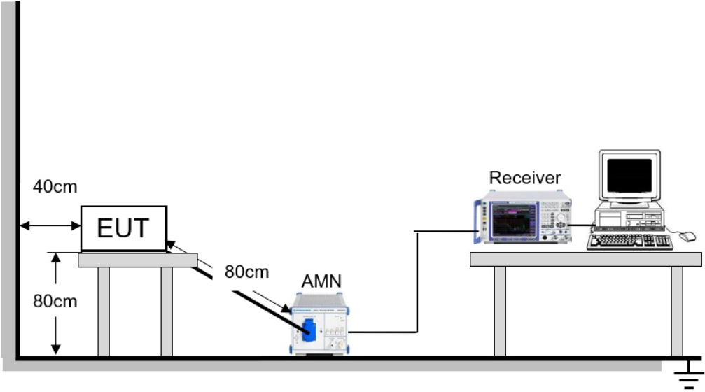
The diagram shows the equipment under test connected to the measurement chain through an artificial mains network (AMN), with the receiver connected to a computer. It marks an equipment height of 80 cm, a distance of 40 cm from the vertical ground plane, and an 80 cm separation between the equipment and AMN.

7.1.3. Test Conditions and Results
Item |  | Information |  |  |  | Item |  |  | Information
Item number |  | LGT25F074 |  |  |  | Test engineer |  |  | LiuH
Product / model |  | Bluetooth Speaker / F33 |  |  |  | Test dates |  |  | 2025-06-12
Test power supply |  | AC 120 V / 60 Hz |  |  |  | Temperature / humidity |  |  | 27℃ / 57%RH
Test mode |  | TX DH5 2402 |  |  |  | Result |  |  | PASS
No. | Frequency  MHz |  | Reading  dBμV | Correction  dB | Level  dBμV |  | Limit  dBμV | Margin  dB |  | Detector | Line
1* | 0.222 |  | 29.12 | 10.61 | 39.73 |  | 62.74 | -23.01 |  | QP | L1
2* | 0.470 |  | 31.81 | 10.57 | 42.38 |  | 56.51 | -14.13 |  | QP | L1
3* | 0.578 |  | 32.64 | 10.57 | 43.21 |  | 56.00 | -12.79 |  | QP | L1
4* | 0.830 |  | 28.77 | 10.62 | 39.39 |  | 56.00 | -16.61 |  | QP | L1
5* | 1.694 |  | 25.37 | 10.90 | 36.27 |  | 56.00 | -19.73 |  | QP | L1
6* | 18.454 |  | 26.26 | 11.56 | 37.82 |  | 60.00 | -22.18 |  | QP | L1
7* | 0.222 |  | 18.02 | 10.61 | 28.63 |  | 52.74 | -24.11 |  | AV | L1
8* | 0.578 |  | 24.98 | 10.57 | 35.55 |  | 46.00 | -10.45 |  | AV | L1
9* | 0.970 |  | 16.99 | 10.68 | 27.67 |  | 46.00 | -18.33 |  | AV | L1
10* | 1.682 |  | 15.28 | 10.89 | 26.17 |  | 46.00 | -19.83 |  | AV | L1
11* | 2.294 |  | 13.80 | 11.05 | 24.85 |  | 46.00 | -21.15 |  | AV | L1
12* | 18.414 |  | 14.22 | 11.55 | 25.77 |  | 50.00 | -24.23 |  | AV | L1
1* | 0.246 |  | 27.34 | 10.57 | 37.91 |  | 61.89 | -23.98 |  | QP | N
2* | 0.578 |  | 26.98 | 10.55 | 37.53 |  | 56.00 | -18.47 |  | QP | N
3* | 0.778 |  | 25.47 | 10.56 | 36.03 |  | 56.00 | -19.97 |  | QP | N
4* | 1.242 |  | 23.23 | 10.59 | 33.82 |  | 56.00 | -22.18 |  | QP | N
5* | 5.342 |  | 15.42 | 10.84 | 26.26 |  | 60.00 | -33.74 |  | QP | N
6* | 12.366 |  | 27.46 | 11.17 | 38.63 |  | 60.00 | -21.37 |  | QP | N
7* | 0.270 |  | 16.69 | 10.58 | 27.27 |  | 51.12 | -23.85 |  | AV | N
8* | 0.578 |  | 15.39 | 10.55 | 25.94 |  | 46.00 | -20.06 |  | AV | N
9* | 0.774 |  | 15.62 | 10.56 | 26.18 |  | 46.00 | -19.82 |  | AV | N
10* | 1.238 |  | 13.10 | 10.59 | 23.69 |  | 46.00 | -22.31 |  | AV | N
11* | 13.610 |  | 6.18 | 11.27 | 17.45 |  | 50.00 | -32.55 |  | AV | N
12* | 19.794 |  | 10.31 | 11.62 | 21.93 |  | 50.00 | -28.07 |  | AV | N
L1 is the live line and N is the neutral line; QP and AV mean quasi-peak and average detection, respectively. The * marks on measurement numbers are retained in the table.
L1 Conducted Emission Spectrum
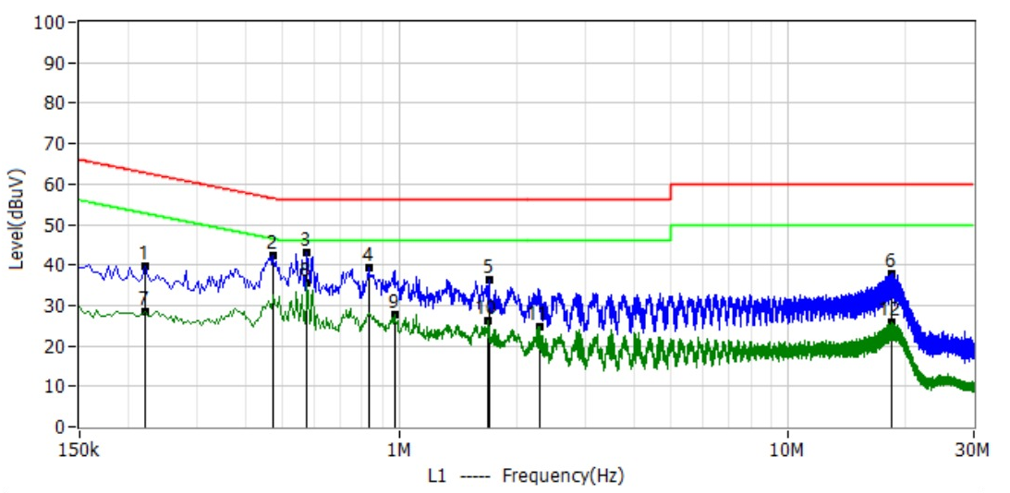
N Conducted Emission Spectrum
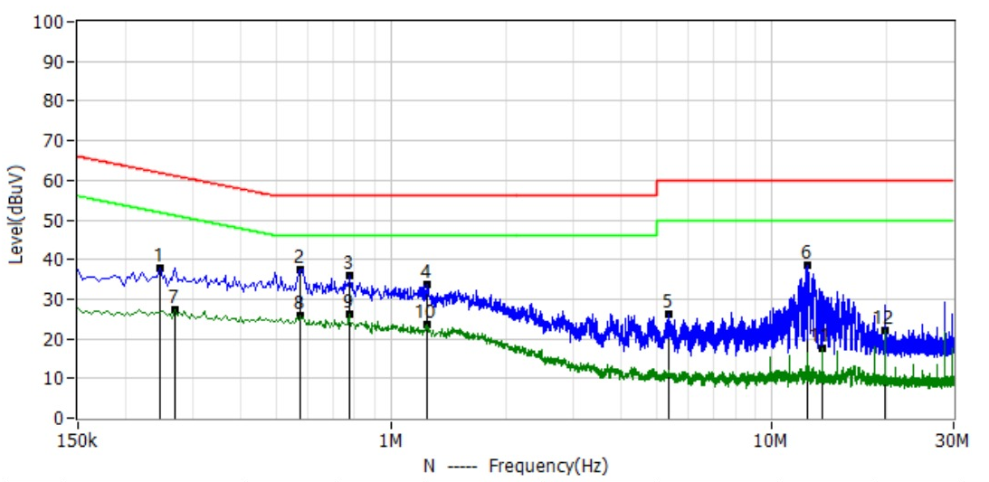
The two spectra plot frequency on the horizontal axis and emission level on the vertical axis, showing the L1 and N measurement curves, quasi-peak and average limit lines, and measurement markers; corresponding readings, correction factors, levels, and margins are listed in the results table.

7.2. Radiated Emissions

7.2.1. Emission Limits and Restricted Bands
Emissions in any 100 kHz bandwidth outside the operating band that fall within the restricted bands listed in Part 15.205(a) and 15.209(a) are evaluated against the following limits and ANSI C63.10-2013. Radiated test limits are based on FCC Part 15C; the stricter limit applies at band boundaries.
Frequency MHz |  | Field strength μV/m |  | Measurement distance m
0.009~0.490 |  | 2400/F(KHz) |  | 300
0.490~1.705 |  | 24000/F(KHz) |  | 30
1.705~30.0 |  | 30 |  | 30
30~88 |  | 100 |  | 3
88~216 |  | 150 |  | 3
216~960 |  | 200 |  | 3
Above 960 |  | 500 |  | 3
Frequency MHz | Peak dBμV/m |  | Average dBμV/m |  | Measurement distance
>1000（1–25 GHz） | 74 |  | 54 |  | 3 m
Emission level (dBμV/m) = 20 log₁₀[emission level (μV/m)].
Restricted bands MHz | Restricted bands MHz | Restricted bands MHz | Restricted bands GHz
0.090-0.110 | 16.42-16.423 | 399.9-410 | 4.5-5.15
0.495-0.505 | 16.69475-16.69525 | 608-614 | 5.35-5.46
2.1735-2.1905 | 16.80425-16.80475 | 960-1240 | 7.25-7.75
4.125-4.128 | 25.5-25.67 | 1300-1427 | 8.025-8.5
4.17725-4.17775 | 37.5-38.25 | 1435-1626.5 | 9.0-9.2
4.20725-4.20775 | 73-74.6 | 1645.5-1646.5 | 9.3-9.5
6.215-6.218 | 74.8-75.2 | 1660-1710 | 10.6-12.7
6.26775-6.26825 | 108-121.94 | 1718.8-1722.2 | 13.25-13.4
6.31175-6.31225 | 123-138 | 2200-2300 | 14.47-14.5
8.291-8.294 | 149.9-150.05 | 2310-2390 | 15.35-16.2
8.362-8.366 | 156.52475-156.52525 | 2483.5-2500 | 17.7-21.4
8.37625-8.38675 | 156.7-156.9 | 2690-2900 | 22.01-23.12
8.41425-8.41475 | 162.0125-167.17 | 3260-3267 | 23.6-24.0
12.29-12.293 | 167.72-173.2 | 3332-3339 | 31.2-31.8
12.51975-12.52025 | 240-285 | 3345.8-3358 | 36.43-36.5
12.57675-12.57725 | 322-335.4 | 3600-4400 | Above 38.6
13.36-13.41

7.2.2. Instrument Settings
Measurement range | Attenuation / detector |  | RBW / VBW
9 kHz–150 kHz | Auto；Peak/QP/AV |  | 200 Hz / 200 Hz
150 kHz–30 MHz | Auto；Peak/QP/AV |  | 9 kHz / 9 kHz
30–1000 MHz | Auto；Peak/QP |  | 120 kHz / 300 kHz
1000 MHz–10th harmonic of the carrier | Auto; Peak (as marked in the settings table); Peak/AV (as marked in the frequency range) |  | Peak: 1 MHz / 3 MHz  ; Average: 1 MHz / (1/T MHz)
Restricted band edges: low end 2310–2410 MHz; high end 2476–2500 MHz | Peak (as marked in the settings table) |  | Peak: 1 MHz / 3 MHz  ; Average: 1 MHz / (1/T MHz)
Receiver frequency range |  | RB |  | Detector
9–90 kHz |  | 200 Hz |  | PK & AV
90–110 kHz |  | 200 Hz |  | QP
110–490 kHz |  | 200 Hz |  | PK & AV
490 kHz–30 MHz |  | 9 kHz |  | QP
30–1000 MHz |  | 120 kHz |  | QP
Receiver attenuation: Auto.

7.2.3. Test Procedure and Operating Conditions
A 3 m measurement distance is used for both 0.009 MHz–1 GHz and above 1 GHz, in a 3 m anechoic chamber. The equipment under test is placed on a turntable, 0.8 m above the ground below 1 GHz and 1.5 m above the ground above 1 GHz; the turntable rotates through 360° to find the position of maximum radiation.
The test antenna height varies from 1–4 m, using both horizontal and vertical polarization. A peak-detector prescan is first performed with a spectrum analyzer, significant peaks are marked, and measurements are repeated using quasi-peak detection. If a peak is already below the quasi-peak limit, no additional quasi-peak measurement is performed.
Both horizontal and vertical polarizations were tested, and prescans were performed on three orthogonal axes to record the worst-case emissions. Deviation from the test standard: none. The equipment uses its normal operating configuration and transmits continuously; see RF_Test Setup photos for the actual configuration.

7.2.4. Test Setup Diagrams
Radiated Emission Setup Below 30 MHz
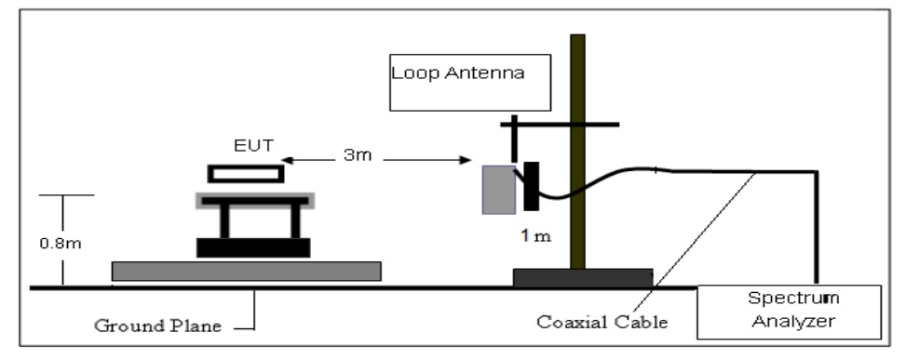
Radiated Emission Setup from 30 MHz–1 GHz
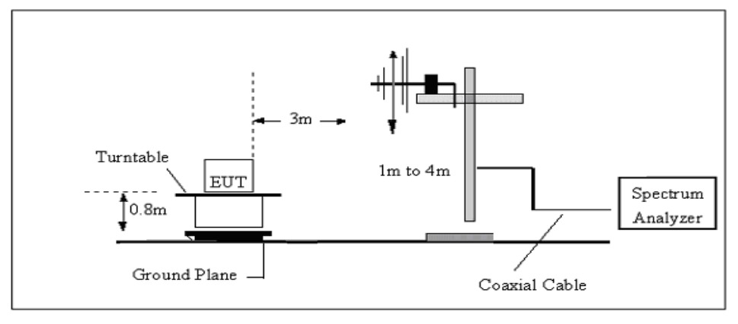
Radiated Emission Setup Above 1 GHz
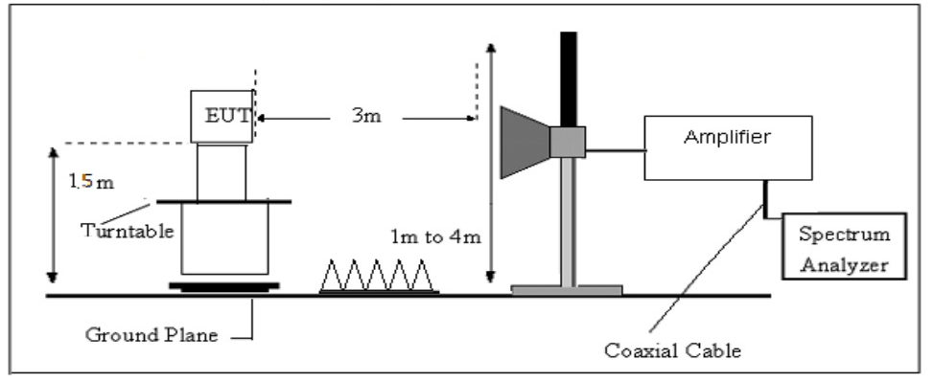
The below-30 MHz setup uses a loop antenna; the 30 MHz–1 GHz setup marks a 0.8 m equipment height, a 3 m measurement distance, and a 1–4 m antenna height; the above-1 GHz setup marks a 1.5 m equipment height and shows absorbing material, the antenna, and the receiving chain.

7.2.5. Field Strength Calculation
Field strength is calculated by adding the antenna factor and cable loss to the measured reading, then subtracting amplifier gain and, where applicable, the duty-cycle correction factor. Basic formulas: FS = RA + AF + CL − AG; Factor = AF + CL − AG.
Symbol |  | Meaning
FS |  | Field Strength
RA |  | Reading Amplitude
AF |  | Antenna Factor
CL |  | Cable Attenuation Factor / Cable Loss
AG |  | Amplifier Gain
Frequency MHz | FS dBμV/m |  | RA dBμV/m | AF dB | CL dB | AG dB | Factor dB
300 | 40 |  | 58.1 | 12.2 | 1.6 | 31.9 | -18.1

7.2.6. 9 kHz–30 MHz Results
Item | Information
Pretest result | Emission levels were 20 dB below the limit; specific values within the permitted range did not need to be recorded.
Result record | No. 1*; frequency, reading, factor, level, limit, margin, and detector are all “—”; remark: See Note.
Distance extrapolation factor | 40 log₁₀(specified distance / test distance), in dB.
Limit line | Specified limit (dBμV) + distance extrapolation factor.

7.2.7. 30–1000 MHz Results
Item | Information | Item | Information
Item number | LGT25F074 | Test engineer | LiuH
Product / model | Bluetooth Speaker / F33 | Test dates | 2025-06-12
Test power supply | Battery | Temperature / humidity | 27℃ / 57%RH
Test mode | TX DH5 2402 | Result | PASS
All modes were tested; the following data represent the worst case. Hor indicates horizontal polarization and Ver indicates vertical polarization.
No. | Frequency  MHz | Reading  dBμV | Factor  dB/m | Level  dBμV/m | Limit  dBμV/m | Margin  dB | Detector | Polarization
1* | 46.005 | 3.01 | 20.71 | 23.72 | 40.00 | -16.28 | QP | Hor
2* | 72.316 | 5.29 | 17.51 | 22.80 | 40.00 | -17.20 | QP | Hor
3* | 155.858 | 3.17 | 22.08 | 25.25 | 43.50 | -18.25 | QP | Hor
4* | 411.453 | 3.20 | 25.72 | 28.92 | 46.00 | -17.08 | QP | Hor
5* | 531.005 | 3.42 | 27.94 | 31.36 | 46.00 | -14.64 | QP | Hor
6* | 704.878 | 3.68 | 31.53 | 35.21 | 46.00 | -10.79 | QP | Hor
1* | 57.160 | 8.00 | 20.24 | 28.24 | 40.00 | -11.76 | QP | Ver
2* | 71.104 | 12.72 | 17.72 | 30.44 | 40.00 | -9.56 | QP | Ver
3* | 93.171 | 19.17 | 16.74 | 35.91 | 43.50 | -7.59 | QP | Ver
4* | 140.823 | 4.99 | 21.60 | 26.59 | 43.50 | -16.91 | QP | Ver
5* | 449.646 | 4.20 | 26.84 | 31.04 | 46.00 | -14.96 | QP | Ver
6* | 887.844 | 5.15 | 34.39 | 39.54 | 46.00 | -6.46 | QP | Ver
30–1000 MHz Horizontal Polarization Spectrum
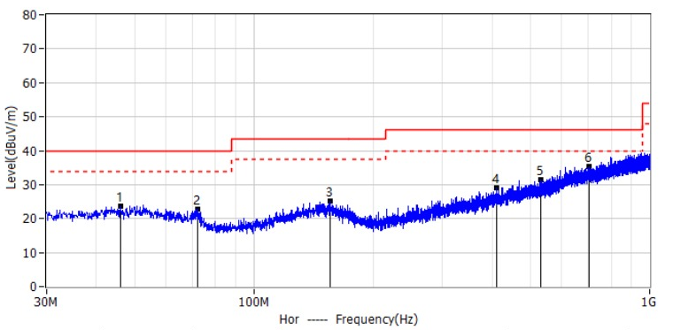
30–1000 MHz Vertical Polarization Spectrum
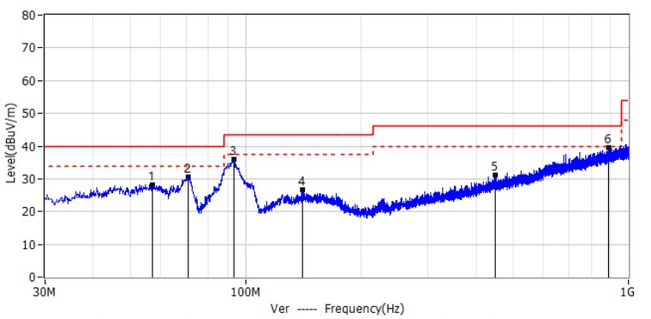
The spectra show frequency versus radiated field strength, overlaid with limit lines and measurement points; the six quasi-peak measurement points for each polarization correspond to the Hor and Ver records in the results table.

7.2.8. Results Above 1000 MHz
All modes were tested; the following data represent the worst case. Vertical and Horizontal indicate the respective polarizations; PK means peak and AV means average.
Channel | Frequency  MHz | Reading  dBμV | Correction  dB | Result  dBμV/m | Limit  dBμV/m | Margin  dB | Detector | Polarization
Low Channel (2402 MHz) | 3264.66 | 55.65 | -8.45 | 47.20 | 74.00 | -26.80 | PK | Vertical
Low Channel (2402 MHz) | 3264.66 | 45.36 | -8.45 | 36.91 | 54.00 | -17.09 | AV | Vertical
Low Channel (2402 MHz) | 3264.75 | 56.22 | -8.45 | 47.77 | 74.00 | -26.23 | PK | Horizontal
Low Channel (2402 MHz) | 3264.75 | 45.94 | -8.45 | 37.49 | 54.00 | -16.51 | AV | Horizontal
Low Channel (2402 MHz) | 4804.28 | 54.17 | -6.09 | 48.08 | 74.00 | -25.92 | PK | Vertical
Low Channel (2402 MHz) | 4804.28 | 45.43 | -6.09 | 39.34 | 54.00 | -14.66 | AV | Vertical
Low Channel (2402 MHz) | 4804.55 | 55.00 | -6.09 | 48.91 | 74.00 | -25.09 | PK | Horizontal
Low Channel (2402 MHz) | 4804.55 | 45.10 | -6.09 | 39.01 | 54.00 | -14.99 | AV | Horizontal
Low Channel (2402 MHz) | 5359.75 | 57.02 | -6.68 | 50.34 | 74.00 | -23.66 | PK | Vertical
Low Channel (2402 MHz) | 5359.75 | 48.39 | -6.68 | 41.71 | 54.00 | -12.29 | AV | Vertical
Low Channel (2402 MHz) | 5359.65 | 57.26 | -6.68 | 50.58 | 74.00 | -23.42 | PK | Horizontal
Low Channel (2402 MHz) | 5359.65 | 47.59 | -6.68 | 40.91 | 54.00 | -13.09 | AV | Horizontal
Low Channel (2402 MHz) | 7205.90 | 60.28 | -8.13 | 52.15 | 74.00 | -21.85 | PK | Vertical
Low Channel (2402 MHz) | 7205.90 | 49.98 | -8.13 | 41.85 | 54.00 | -12.15 | AV | Vertical
Low Channel (2402 MHz) | 7205.69 | 60.31 | -8.13 | 52.18 | 74.00 | -21.82 | PK | Horizontal
Low Channel (2402 MHz) | 7205.69 | 50.06 | -8.13 | 41.93 | 54.00 | -12.07 | AV | Horizontal
Middle Channel (2441 MHz) | 3264.60 | 56.46 | -8.45 | 48.01 | 74.00 | -25.99 | PK | Vertical
Middle Channel (2441 MHz) | 3264.60 | 45.70 | -8.45 | 37.25 | 54.00 | -16.75 | AV | Vertical
Middle Channel (2441 MHz) | 3264.70 | 56.49 | -8.45 | 48.04 | 74.00 | -25.96 | PK | Horizontal
Middle Channel (2441 MHz) | 3264.70 | 46.50 | -8.45 | 38.05 | 54.00 | -15.95 | AV | Horizontal
Middle Channel (2441 MHz) | 4882.31 | 54.74 | -6.09 | 48.65 | 74.00 | -25.35 | PK | Vertical
Middle Channel (2441 MHz) | 4882.31 | 44.62 | -6.09 | 38.53 | 54.00 | -15.47 | AV | Vertical
Middle Channel (2441 MHz) | 4882.32 | 54.06 | -6.09 | 47.97 | 74.00 | -26.03 | PK | Horizontal
Middle Channel (2441 MHz) | 4882.32 | 44.39 | -6.09 | 38.30 | 54.00 | -15.70 | AV | Horizontal
Middle Channel (2441 MHz) | 5359.82 | 57.87 | -6.68 | 51.19 | 74.00 | -22.81 | PK | Vertical
Middle Channel (2441 MHz) | 5359.82 | 47.71 | -6.68 | 41.03 | 54.00 | -12.97 | AV | Vertical
Middle Channel (2441 MHz) | 5359.60 | 57.67 | -6.68 | 50.99 | 74.00 | -23.01 | PK | Horizontal
Middle Channel (2441 MHz) | 5359.60 | 48.17 | -6.68 | 41.49 | 54.00 | -12.51 | AV | Horizontal
Middle Channel (2441 MHz) | 7313.71 | 60.30 | -8.13 | 52.17 | 74.00 | -21.83 | PK | Vertical
Middle Channel (2441 MHz) | 7313.71 | 49.54 | -8.13 | 41.41 | 54.00 | -12.59 | AV | Vertical
Middle Channel (2441 MHz) | 7313.82 | 60.72 | -8.13 | 52.59 | 74.00 | -21.41 | PK | Horizontal
Middle Channel (2441 MHz) | 7313.82 | 49.91 | -8.13 | 41.78 | 54.00 | -12.22 | AV | Horizontal
High Channel (2480 MHz) | 3264.62 | 56.01 | -8.45 | 47.56 | 74.00 | -26.44 | PK | Vertical
High Channel (2480 MHz) | 3264.62 | 45.78 | -8.45 | 37.33 | 54.00 | -16.67 | AV | Vertical
High Channel (2480 MHz) | 3264.69 | 55.82 | -8.45 | 47.37 | 74.00 | -26.63 | PK | Horizontal
High Channel (2480 MHz) | 3264.69 | 45.04 | -8.45 | 36.59 | 54.00 | -17.41 | AV | Horizontal
High Channel (2480 MHz) | 4960.41 | 54.32 | -6.09 | 48.23 | 74.00 | -25.77 | PK | Vertical
High Channel (2480 MHz) | 4960.41 | 45.12 | -6.09 | 39.03 | 54.00 | -14.97 | AV | Vertical
High Channel (2480 MHz) | 4960.47 | 54.62 | -6.09 | 48.53 | 74.00 | -25.47 | PK | Horizontal
High Channel (2480 MHz) | 4960.47 | 44.93 | -6.09 | 38.84 | 54.00 | -15.16 | AV | Horizontal
High Channel (2480 MHz) | 5359.61 | 57.34 | -6.68 | 50.66 | 74.00 | -23.34 | PK | Vertical
High Channel (2480 MHz) | 5359.61 | 47.91 | -6.68 | 41.23 | 54.00 | -12.77 | AV | Vertical
High Channel (2480 MHz) | 5359.63 | 57.53 | -6.68 | 50.85 | 74.00 | -23.15 | PK | Horizontal
High Channel (2480 MHz) | 5359.63 | 47.53 | -6.68 | 40.85 | 54.00 | -13.15 | AV | Horizontal
High Channel (2480 MHz) | 7439.78 | 59.92 | -8.13 | 51.79 | 74.00 | -22.21 | PK | Vertical
High Channel (2480 MHz) | 7439.78 | 50.97 | -8.13 | 42.84 | 54.00 | -11.16 | AV | Vertical
High Channel (2480 MHz) | 7439.87 | 59.60 | -8.13 | 51.47 | 74.00 | -22.53 | PK | Horizontal
High Channel (2480 MHz) | 7439.87 | 50.31 | -8.13 | 42.18 | 54.00 | -11.82 | AV | Horizontal
No other harmonic emissions requiring separate recording were detected in the 18–25 GHz range; other emissions were at least 20 dB below the limits and were not separately recorded.

7.2.9. Radiated Band-Edge Results
Low-end measurement frequency range: 2310–2404 MHz; high-end measurement frequency range: 2478–2500 MHz.
Modulation | Frequency  MHz | Reading  dBμV | Correction  dB | Result  dBμV/m | Limit  dBμV/m | Margin  dB | Detector | Polarization
GFSK | 2390.00 | 12.75 | 34.10 | 46.85 | 74.00 | -27.15 | PK | Vertical
GFSK | 2390.00 | 1.46 | 34.10 | 35.56 | 54.00 | -18.44 | AV | Vertical
GFSK | 2400.00 | 12.31 | 34.11 | 46.42 | 74.00 | -27.58 | PK | Vertical
GFSK | 2400.00 | 1.10 | 34.11 | 35.21 | 54.00 | -18.79 | AV | Vertical
GFSK | 2390.00 | 15.10 | 34.11 | 49.21 | 74.00 | -24.79 | PK | Horizontal
GFSK | 2390.00 | 1.96 | 34.11 | 36.07 | 54.00 | -17.93 | AV | Horizontal
GFSK | 2400.00 | 14.44 | 34.11 | 48.55 | 74.00 | -25.45 | PK | Horizontal
GFSK | 2400.00 | 3.25 | 34.11 | 37.36 | 54.00 | -16.64 | AV | Horizontal
GFSK | 2483.50 | 12.45 | 34.44 | 46.89 | 74.00 | -27.11 | PK | Vertical
GFSK | 2483.50 | 2.29 | 34.44 | 36.73 | 54.00 | -17.27 | AV | Vertical
GFSK | 2500.00 | 13.26 | 34.46 | 47.72 | 74.00 | -26.28 | PK | Vertical
GFSK | 2500.00 | 1.81 | 34.46 | 36.27 | 54.00 | -17.73 | AV | Vertical
GFSK | 2483.50 | 15.04 | 34.46 | 49.50 | 74.00 | -24.50 | PK | Horizontal
GFSK | 2483.50 | 3.24 | 34.46 | 37.70 | 54.00 | -16.30 | AV | Horizontal
GFSK | 2500.00 | 14.91 | 34.46 | 49.37 | 74.00 | -24.63 | PK | Horizontal
GFSK | 2500.00 | 1.98 | 34.46 | 36.44 | 54.00 | -17.56 | AV | Horizontal
π/4-DQPSK | 2390.00 | 13.29 | 34.10 | 47.39 | 74.00 | -26.61 | PK | Vertical
π/4-DQPSK | 2390.00 | 0.89 | 34.10 | 34.99 | 54.00 | -19.01 | AV | Vertical
π/4-DQPSK | 2400.00 | 13.58 | 34.11 | 47.69 | 74.00 | -26.31 | PK | Vertical
π/4-DQPSK | 2400.00 | 1.85 | 34.11 | 35.96 | 54.00 | -18.04 | AV | Vertical
π/4-DQPSK | 2390.00 | 15.24 | 34.11 | 49.35 | 74.00 | -24.65 | PK | Horizontal
π/4-DQPSK | 2390.00 | 2.97 | 34.11 | 37.08 | 54.00 | -16.92 | AV | Horizontal
π/4-DQPSK | 2400.00 | 15.25 | 34.11 | 49.36 | 74.00 | -24.64 | PK | Horizontal
π/4-DQPSK | 2400.00 | 2.84 | 34.11 | 36.95 | 54.00 | -17.05 | AV | Horizontal
π/4-DQPSK | 2483.50 | 13.10 | 34.44 | 47.54 | 74.00 | -26.46 | PK | Vertical
π/4-DQPSK | 2483.50 | 1.58 | 34.44 | 36.02 | 54.00 | -17.98 | AV | Vertical
π/4-DQPSK | 2500.00 | 12.34 | 34.46 | 46.80 | 74.00 | -27.20 | PK | Vertical
π/4-DQPSK | 2500.00 | 1.73 | 34.46 | 36.19 | 54.00 | -17.81 | AV | Vertical
π/4-DQPSK | 2483.50 | 14.75 | 34.46 | 49.21 | 74.00 | -24.79 | PK | Horizontal
π/4-DQPSK | 2483.50 | 2.55 | 34.46 | 37.01 | 54.00 | -16.99 | AV | Horizontal
π/4-DQPSK | 2500.00 | 15.45 | 34.46 | 49.91 | 74.00 | -24.09 | PK | Horizontal
π/4-DQPSK | 2500.00 | 2.24 | 34.46 | 36.70 | 54.00 | -17.30 | AV | Horizontal
8DPSK | 2390.00 | 13.39 | 34.10 | 47.49 | 74.00 | -26.51 | PK | Vertical
8DPSK | 2390.00 | 1.36 | 34.10 | 35.46 | 54.00 | -18.54 | AV | Vertical
8DPSK | 2400.00 | 13.52 | 34.11 | 47.63 | 74.00 | -26.37 | PK | Vertical
8DPSK | 2400.00 | 2.37 | 34.11 | 36.48 | 54.00 | -17.52 | AV | Vertical
8DPSK | 2390.00 | 15.26 | 34.11 | 49.37 | 74.00 | -24.63 | PK | Horizontal
8DPSK | 2390.00 | 2.92 | 34.11 | 37.03 | 54.00 | -16.97 | AV | Horizontal
8DPSK | 2400.00 | 14.36 | 34.11 | 48.47 | 74.00 | -25.53 | PK | Horizontal
8DPSK | 2400.00 | 2.32 | 34.11 | 36.43 | 54.00 | -17.57 | AV | Horizontal
8DPSK | 2483.50 | 13.71 | 34.44 | 48.15 | 74.00 | -25.85 | PK | Vertical
8DPSK | 2483.50 | 0.95 | 34.44 | 35.39 | 54.00 | -18.61 | AV | Vertical
8DPSK | 2500.00 | 12.43 | 34.46 | 46.89 | 74.00 | -27.11 | PK | Vertical
8DPSK | 2500.00 | 1.12 | 34.46 | 35.58 | 54.00 | -18.42 | AV | Vertical
8DPSK | 2483.50 | 13.95 | 34.46 | 48.41 | 74.00 | -25.59 | PK | Horizontal
8DPSK | 2483.50 | 2.04 | 34.46 | 36.50 | 54.00 | -17.50 | AV | Horizontal
8DPSK | 2500.00 | 14.58 | 34.46 | 49.04 | 74.00 | -24.96 | PK | Horizontal
8DPSK | 2500.00 | 2.68 | 34.46 | 37.14 | 54.00 | -16.86 | AV | Horizontal

8. Conducted Spurious and Band-Edge Emissions

8.1. Limits
FCC 15.247(d): RF power in any 100 kHz bandwidth outside the operating band of a spread spectrum or digitally modulated intentional radiator must be at least 20 dB below the power in the 100 kHz bandwidth containing the highest desired power within the operating band; RF conducted or radiated measurements may be used.

8.2. Test Settings
Item | Scan range | RBW / VBW | Detector / trace
Conducted spurious emissions | 30 MHz–10th harmonic of the carrier | 100 kHz / 300 kHz | Peak / Max hold
Fixed-channel band edges | Low end: 2300–2407 MHz  ; High end: 2475–2500 MHz | 100 kHz / 300 kHz | Peak / Max hold
Hopping band edges | Low end: 2300–2403 MHz  ; High end: 2479–2500 MHz | 100 kHz / 300 kHz | Peak / Max hold

8.3. Connections and Operating Conditions
The equipment under test is connected to a spectrum analyzer, with a 50 Ω RF load at the antenna port. Path loss is calibrated and used as a correction factor to compensate readings. RBW is set to 100 kHz; for accurate measurement, the frequency span is set greater than RBW.
The equipment is configured for normal operation and transmits continuously.
Conducted Spurious and Band-Edge Test Connection
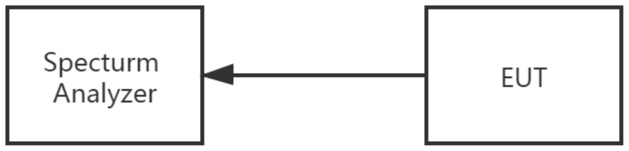
The connection diagram shows the EUT antenna port connected to the Spectrum Analyzer.

8.4. Test result
Assessment: PASS. See 15.3. for conducted spurious measurement data; high-end band-edge, hopping band-edge, and low-end band-edge spectra are shown in 15.7., 15.8., and 15.9., respectively.
Emissions from 9 kHz–30 MHz were at least 20 dBc below the emission limits and were not recorded.

9. Number of Hopping Channels

9.1. Limits and Assessment
Standard clause | Frequency range MHz | Limits | Assessment
15.247(a)(1)(iii) | 2400–2483.5 | ≥15 channels | PASS

9.2. Method and Instrument Settings
The equipment's antenna output port is connected directly to a spectrum analyzer.
Item | Information
Attenuation | Auto
Frequency span | Greater than the operating frequency range
RBW / VBW | 300 kHz / 300 kHz
Detector / trace | Peak / Max Hold
Sweep time | Auto

9.3. Test Setup and Results
Hopping Channel Count Test Connection
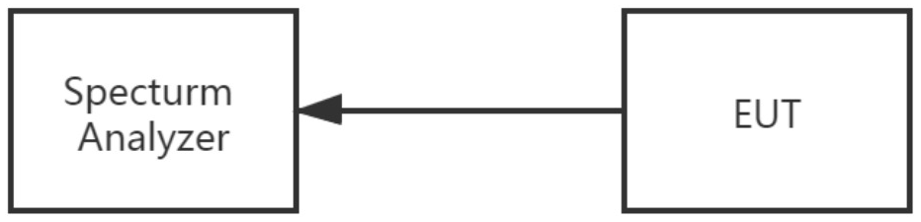
The connection diagram shows the EUT antenna output port connected to a spectrum analyzer. The equipment is configured for normal operation and transmits continuously.
DH5, 2DH5, and 3DH5 each had 79 hopping channels, assessed as Pass; complete data and spectra are provided in 15.1.

10. Average Time of Occupancy

10.1. Limits and Assessment
Standard clause | Frequency range MHz | Limits | Assessment
15.247(a)(1)(iii) | 2400–2483.5 | 0.4 sec | PASS

10.2. Measurement Steps and Observation Period
Connect the transmitter antenna port to a spectrum analyzer; RBW=1 MHz, VBW=3 MHz. Use video triggering, setting the trigger level to trigger only on complete pulses; set the sweep time longer than the duration of a single pulse.
Set the center frequency to the frequency under test and the span to zero span, then measure the maximum duration of a single pulse. Set the equipment to transmit DH5, DH3, and DH1 packets in turn and measure the maximum single-pulse duration.
Packet | Slot configuration | Hops per channel per second | Pulses within 31.6 s
DH5 | 5 RX slots, 1 TX slot | 1600 / 79 / 6 = 3.37 | 3.37 × 31.6 = 106.6
DH3 | 3 RX slots, 1 TX slot | 1600 / 79 / 4 = 5.06 | 5.06 × 31.6 = 160
DH1 | 1 RX slot, 1 TX slot | 1600 / 79 / 2 = 10.12 | 10.12 × 31.6 = 320

10.3. Test Setup and Results
Average Time of Occupancy Test Connection
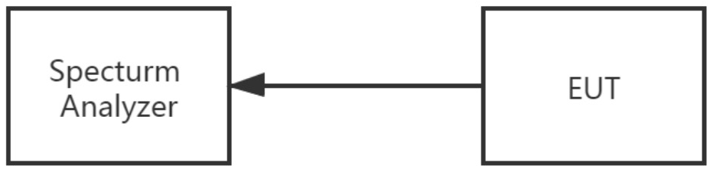
The connection diagram shows the EUT antenna output port connected to a spectrum analyzer. The equipment is configured for normal operation and transmits continuously.
The recorded 1-DH5, 2-DH5, and 3-DH5 results at 2441 MHz all show a pulse duration of 2.880 ms and dwell time of 307 ms, against a limit of 400 ms, assessed as Pass. Data and pulse plots are provided in 15.6.

11. Hopping Channel Separation Measurement

11.1. Limits
Hopping channel carrier frequencies must be separated by at least 25 kHz or the hopping channel's 20 dB bandwidth, whichever is greater.
For the 2400–2483.5 MHz band, if system output power does not exceed 125 mW, separation may be at least 25 kHz or 2/3 of the hopping channel's 20 dB bandwidth, whichever is greater.

11.2. Method and Instrument Settings
Connect the transmitter antenna port to a spectrum analyzer in peak-hold mode; use RBW 30 kHz and VBW 100 kHz for both 20 dB bandwidth and channel separation measurements.
Item | Information
Attenuation | Auto
Frequency span | Greater than the 20 dB bandwidth or channel separation
RBW / VBW | 30 kHz / 100 kHz
Detector / trace | Peak / Max Hold
Sweep time | Auto

11.3. Test Setup and Results
Hopping Channel Separation Test Connection
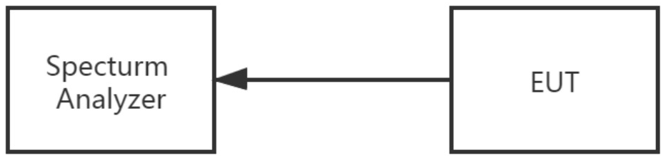
The connection diagram shows the EUT antenna output port connected to a spectrum analyzer. The equipment is configured for normal operation and transmits continuously.
Assessment: PASS. See 15.5. for low-, middle-, and high-channel separation values, corresponding limits, and spectra for DH5, 2DH5, and 3DH5.

12. Bandwidth Test

12.1. Limits and Assessment
Standard clause | Frequency range MHz | Limit | Assessment
15.247(a)(1) | 2400–2483.5 | N/A | PASS

12.2. Method and Instrument Settings
The equipment's antenna port is connected directly to a spectrum analyzer.
Item | Information
Attenuation | Auto
Frequency span | Greater than the measurement bandwidth or channel separation
RBW | 20 dB bandwidth: 30 kHz; channel separation: 30 kHz
VBW | 20 dB bandwidth: 100 kHz; channel separation: 100 kHz
Detector / trace | Peak / Max Hold
Sweep time | Auto

12.3. Test Setup and Results
Bandwidth Test Connection
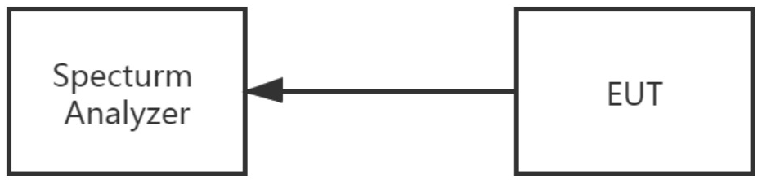
The connection diagram shows the EUT antenna output port connected to a spectrum analyzer. The equipment is configured for normal operation and transmits continuously.
See 15.4. for the nine sets of 99% occupied bandwidth and 20 dB bandwidth results, the appendix Limit field (7 MHz), and measurement plots.

13. Output Power Test

13.1. Limits and Assessment
Item | Information
Standard clause | 15.247(a)(1)&(b)(1)
Frequency range | 2400–2483.5 MHz
Limits | 1 W or 0.125 W; when channel separation >2/3 bandwidth, system output power must not exceed 125 mW (20.97 dBm).
Assessment | PASS

13.2. Spectrum Analyzer Method
Measure maximum peak output power using the RF conducted method. Connect the equipment's antenna port to a spectrum analyzer through appropriate attenuation and disable frequency hopping during testing.
Item | Information
Frequency span | Approximately 5 times the 20 dB bandwidth, centered on a hopping channel
RBW | Greater than the 20 dB bandwidth of the emission under test
VBW | ≥RBW
Sweep | Auto
Detector | Peak
Trace | Max hold
Once the trace is stable, use the marker-to-peak function to place the marker at the emission peak. After correction for external attenuators and cables, the indicated level is the peak output power. Test requirements include result plots and configuration descriptions.

13.3. Peak Power Meter Method
A peak-responding power meter may replace the spectrum analyzer; the video bandwidth of the power meter and sensor system should exceed the equipment's occupied bandwidth.
The PKPM1 method uses a wideband peak RF power meter to measure maximum peak conducted output power; the meter's video bandwidth must be greater than or equal to the DSS bandwidth, using a fast-response diode detector.

13.4. Test Setup and Results
Peak Output Power Test Connection
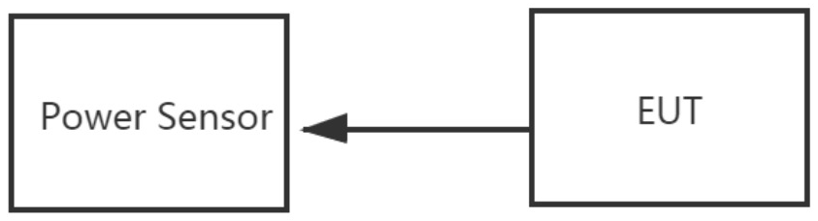
The connection diagram shows the EUT connected to a Power Sensor. The equipment uses its normal operating configuration and transmits continuously. See 15.2. for the nine sets of peak output power data and the results table limit of 21 dBm.

14. Antenna Requirements

14.1. Standard Requirements
FCC 15.203: An intentional radiator must be designed to ensure that only the antenna supplied by the responsible party can be used with the equipment.

14.2. Equipment Under Test Antenna
Item | Information
Antenna type | PCB Antenna
Antenna gain | -0.58 dBi
Assessment | Meets the standard requirements; PASS.

15. Test Results Appendix

15.1. Number of Hopping Frequencies
Mode | RBW MHz | Detector | Channel count | Limit | Assessment
DH5 | 0.3 | Peak | 79 | 15 | Pass
2DH5 | 0.3 | Peak | 79 | 15 | Pass
3DH5 | 0.3 | Peak | 79 | 15 | Pass
The spectra show the distribution of hopping channel peaks for each mode, displaying the operating band in segments alongside the channel count result of 79.
DH5 Hopping Spectrum (Two Scan Ranges)
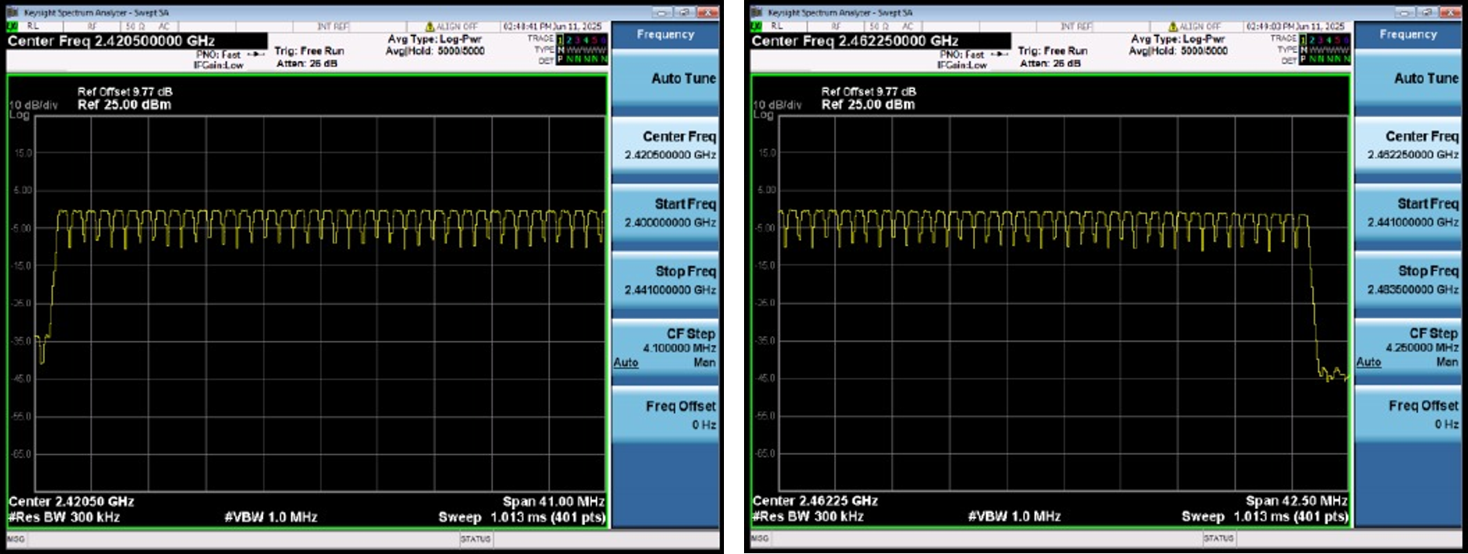
2DH5 Hopping Spectrum (Two Scan Ranges)
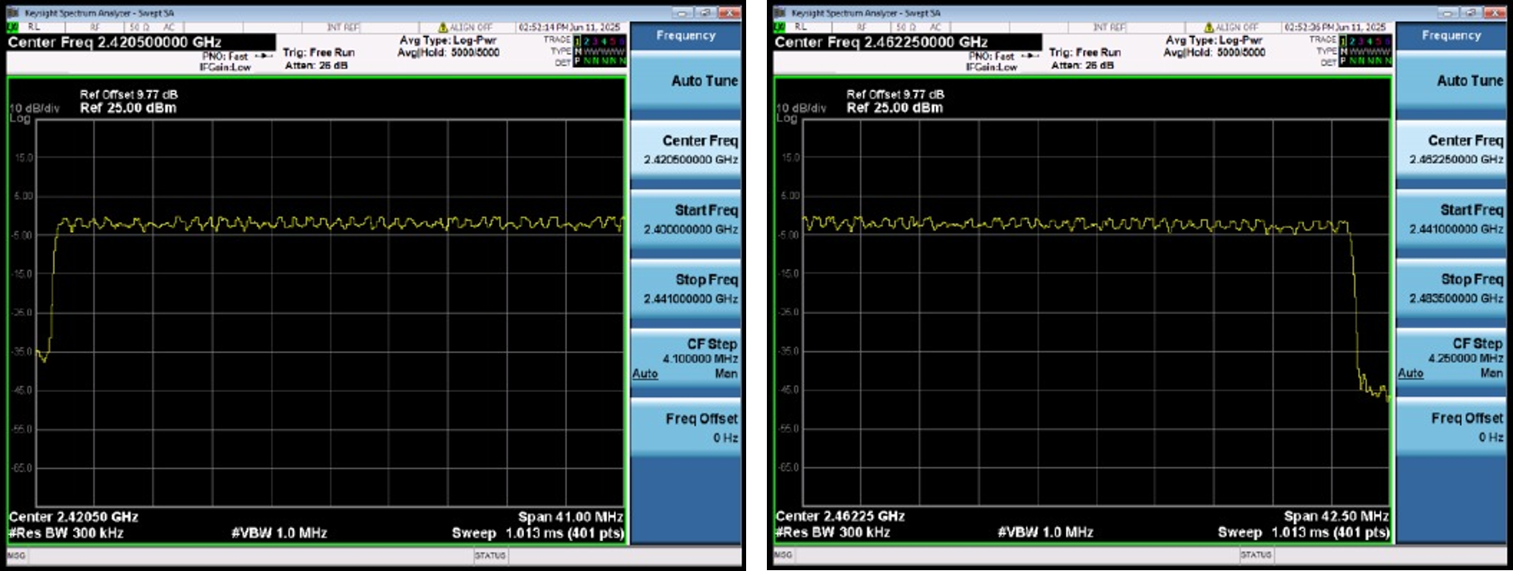
3DH5 Hopping Spectrum (Two Scan Ranges)
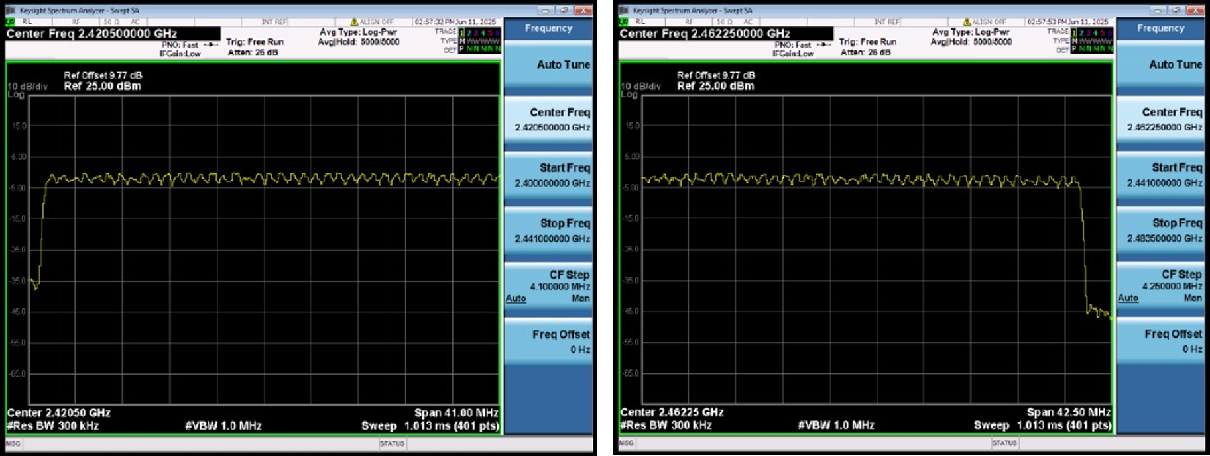

15.2. Peak Output Power
Frequency MHz | Mode | Detector | Level dBm | Limit dBm | Assessment
2402 | DH5 | Peak | -1.1 | 21 | Pass
2441 | DH5 | Peak | -1.07 | 21 | Pass
2480 | DH5 | Peak | -2.05 | 21 | Pass
2402 | 2DH5 | Peak | -0.21 | 21 | Pass
2441 | 2DH5 | Peak | -0.21 | 21 | Pass
2480 | 2DH5 | Peak | -1.15 | 21 | Pass
2402 | 3DH5 | Peak | 0.18 | 21 | Pass
2441 | 3DH5 | Peak | 0.19 | 21 | Pass
2480 | 3DH5 | Peak | -0.76 | 21 | Pass

15.3. Conducted Spurious Emissions
Each set of plots contains, in order, the spectrum near the carrier, a lower-frequency spurious scan, and a higher-frequency spurious scan; the numerical table lists spurious measurement frequencies and levels. Record numbers follow the order of the A.3 measurement groups.
Record number | Mode | Spurious frequency MHz | Level dBm
1 | DH5 | 2453.52 | -33.231
1 | DH5 | 21147.5 | -40.798
2 | DH5 | 2450.55 | -30.435
2 | DH5 | 5243 | -39.529
3 | DH5 | 2450.55 | -33.163
3 | DH5 | 4955.5 | -46.132
4 | 2DH5 | 2462.43 | -46.128
4 | 2DH5 | 4800.25 | -44.472
5 | 2DH5 | 2450.55 | -33.026
5 | 2DH5 | 4880.75 | -46.923
6 | 2DH5 | 2453.52 | -32.336
6 | 2DH5 | 5243 | -43.262
7 | 3DH5 | 2450.55 | -32.74
7 | 3DH5 | 4800.25 | -45.383
8 | 3DH5 | 2453.52 | -35.236
8 | 3DH5 | 21647.75 | -41.093
9 | 3DH5 | 2450.55 | -39.131
9 | 3DH5 | 21159 | -40.615

15.3.1. DH5 Spurious Measurement Record 1
Upper left: spectrum near the carrier; upper right: lower-frequency spurious emissions; lower left: higher-frequency spurious emissions
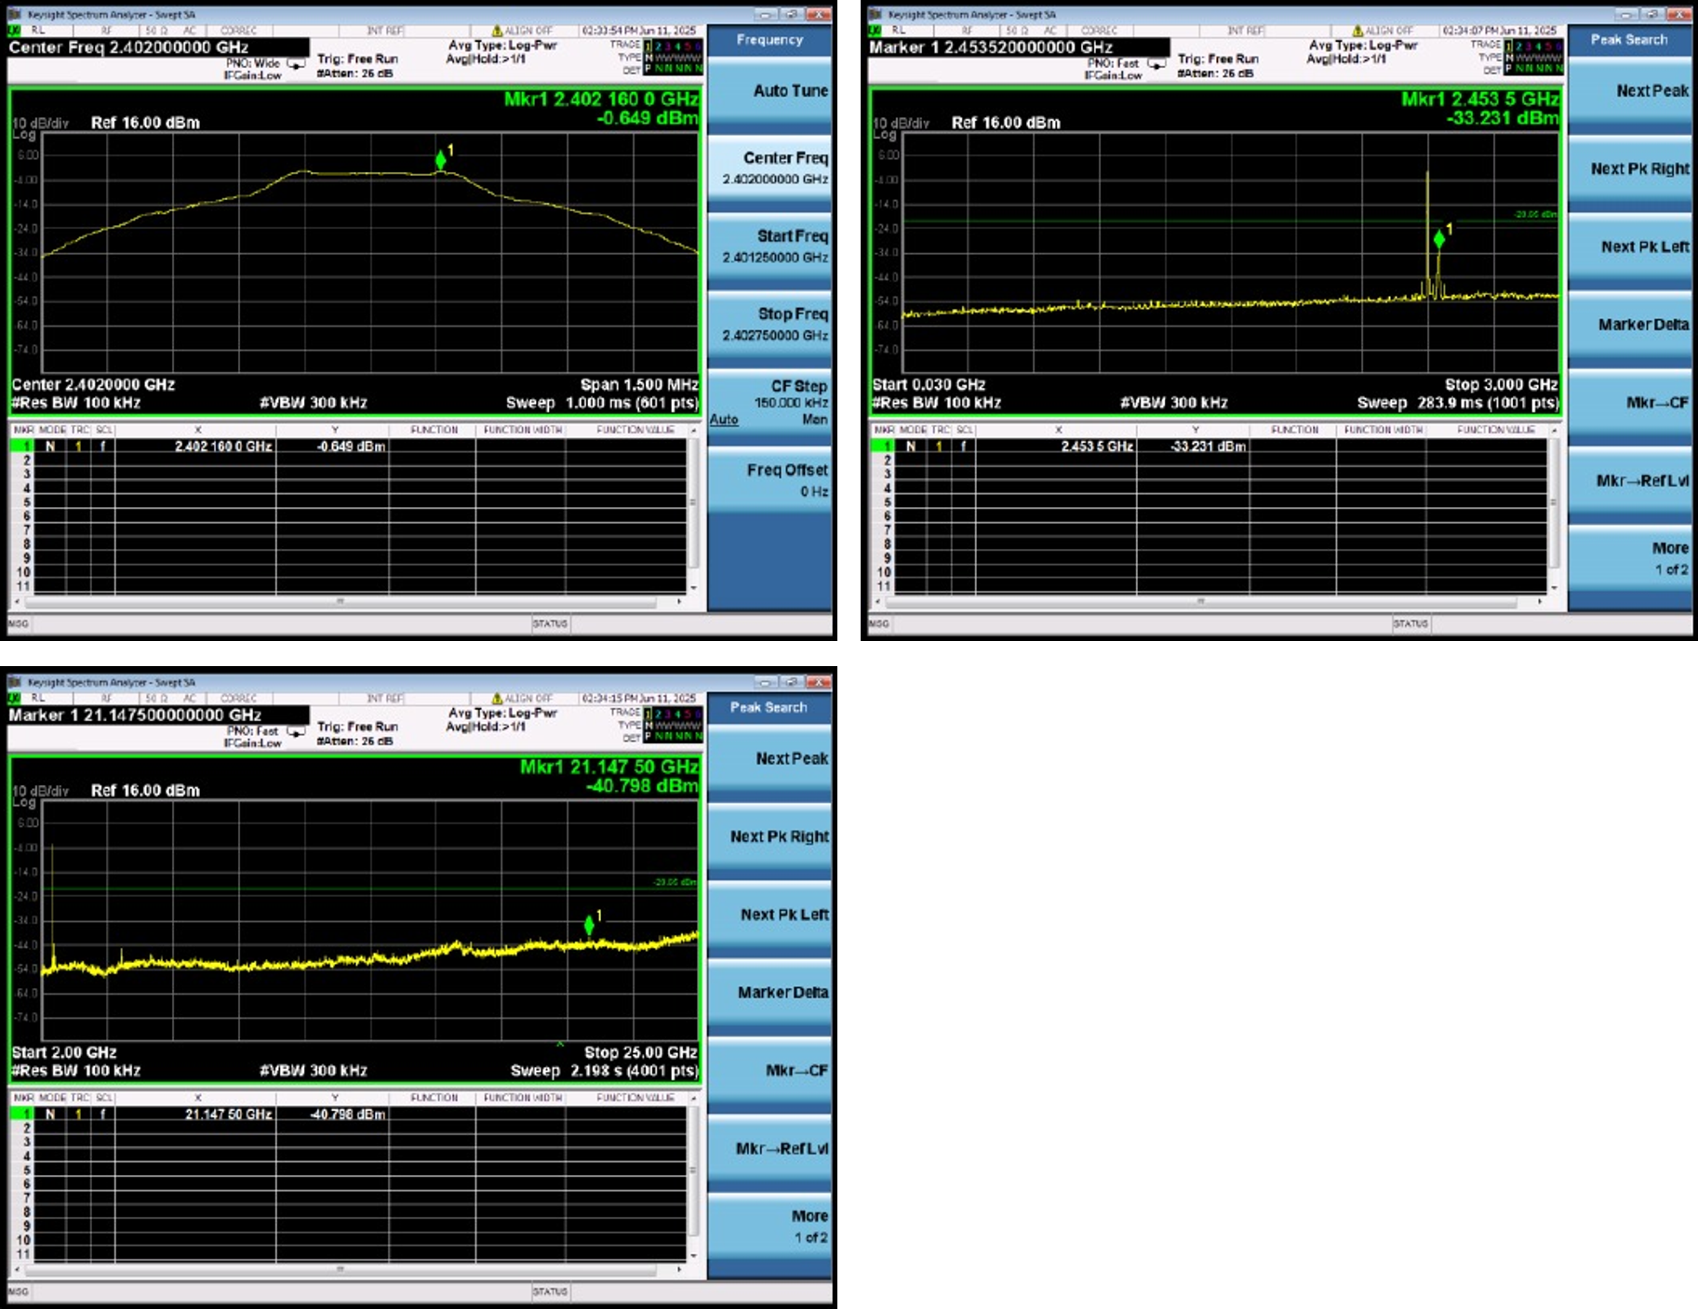

15.3.2. DH5 Spurious Measurement Record 2
Upper left: spectrum near the carrier; upper right: lower-frequency spurious emissions; lower left: higher-frequency spurious emissions
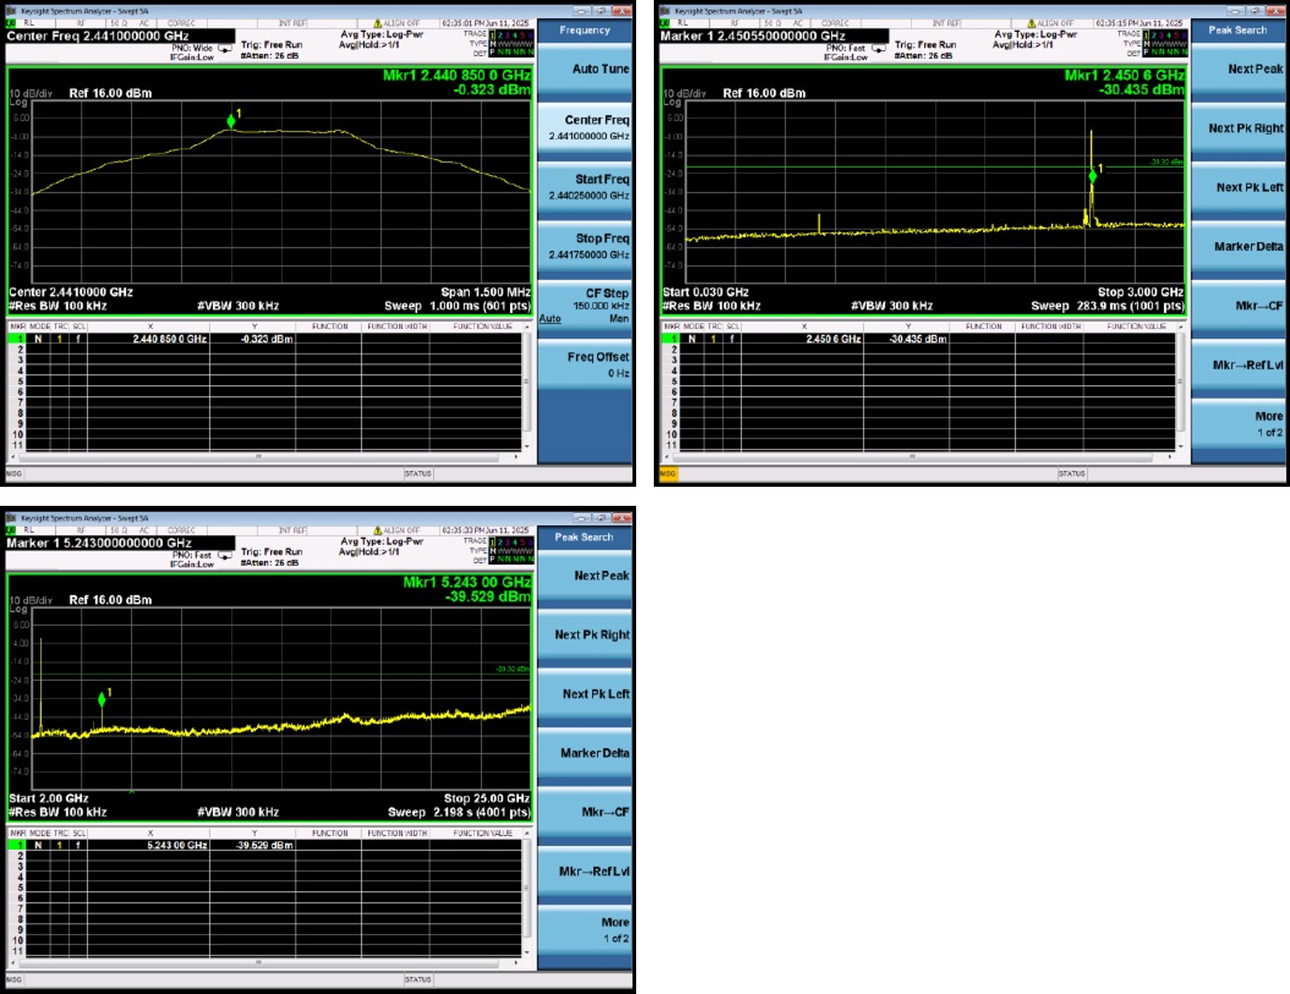

15.3.3. DH5 Spurious Measurement Record 3
Upper left: spectrum near the carrier; upper right: lower-frequency spurious emissions; lower left: higher-frequency spurious emissions
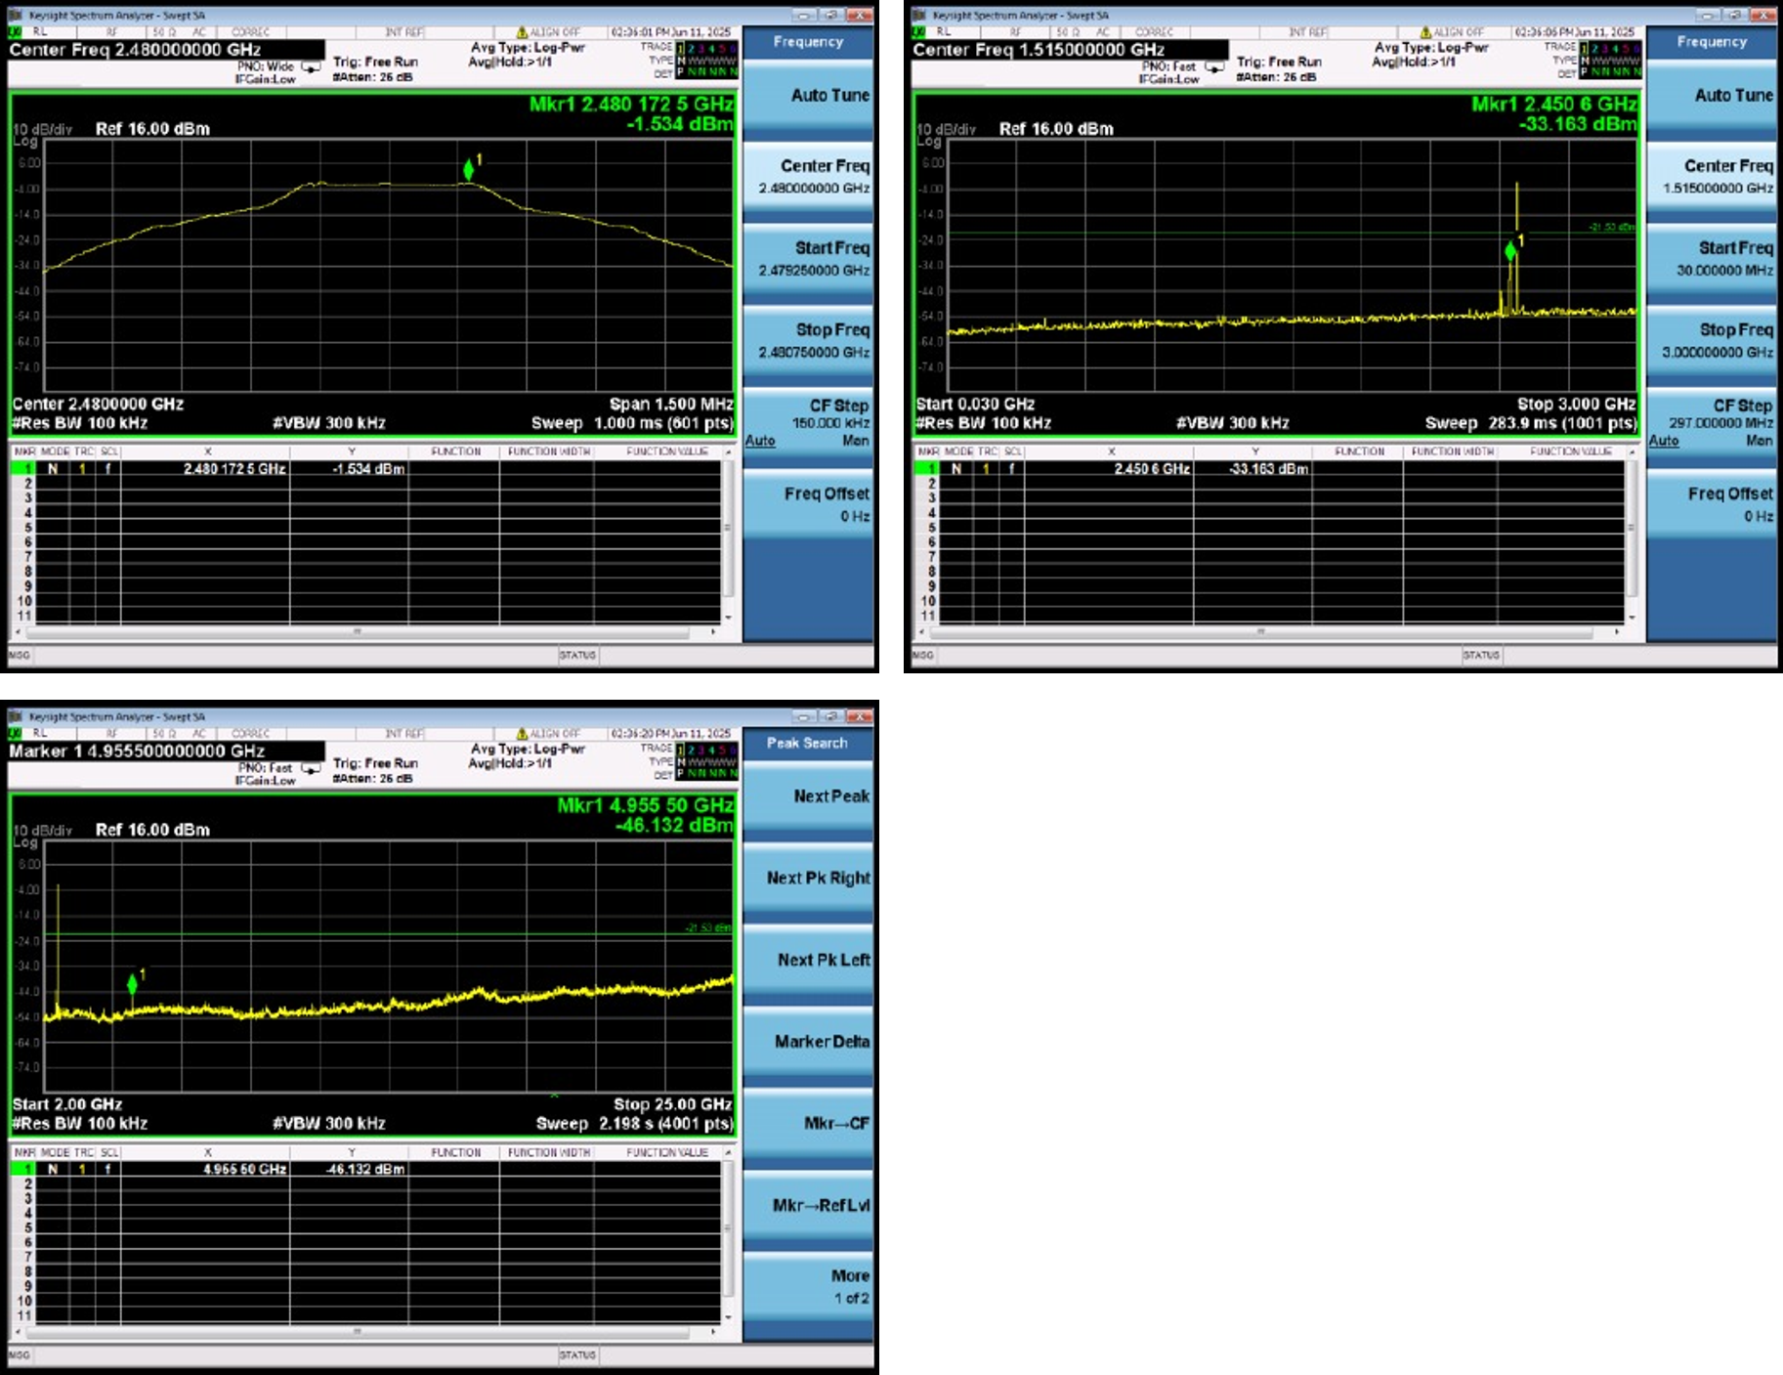

15.3.4. 2DH5 Spurious Measurement Record 4
Upper left: spectrum near the carrier; upper right: lower-frequency spurious emissions; lower left: higher-frequency spurious emissions
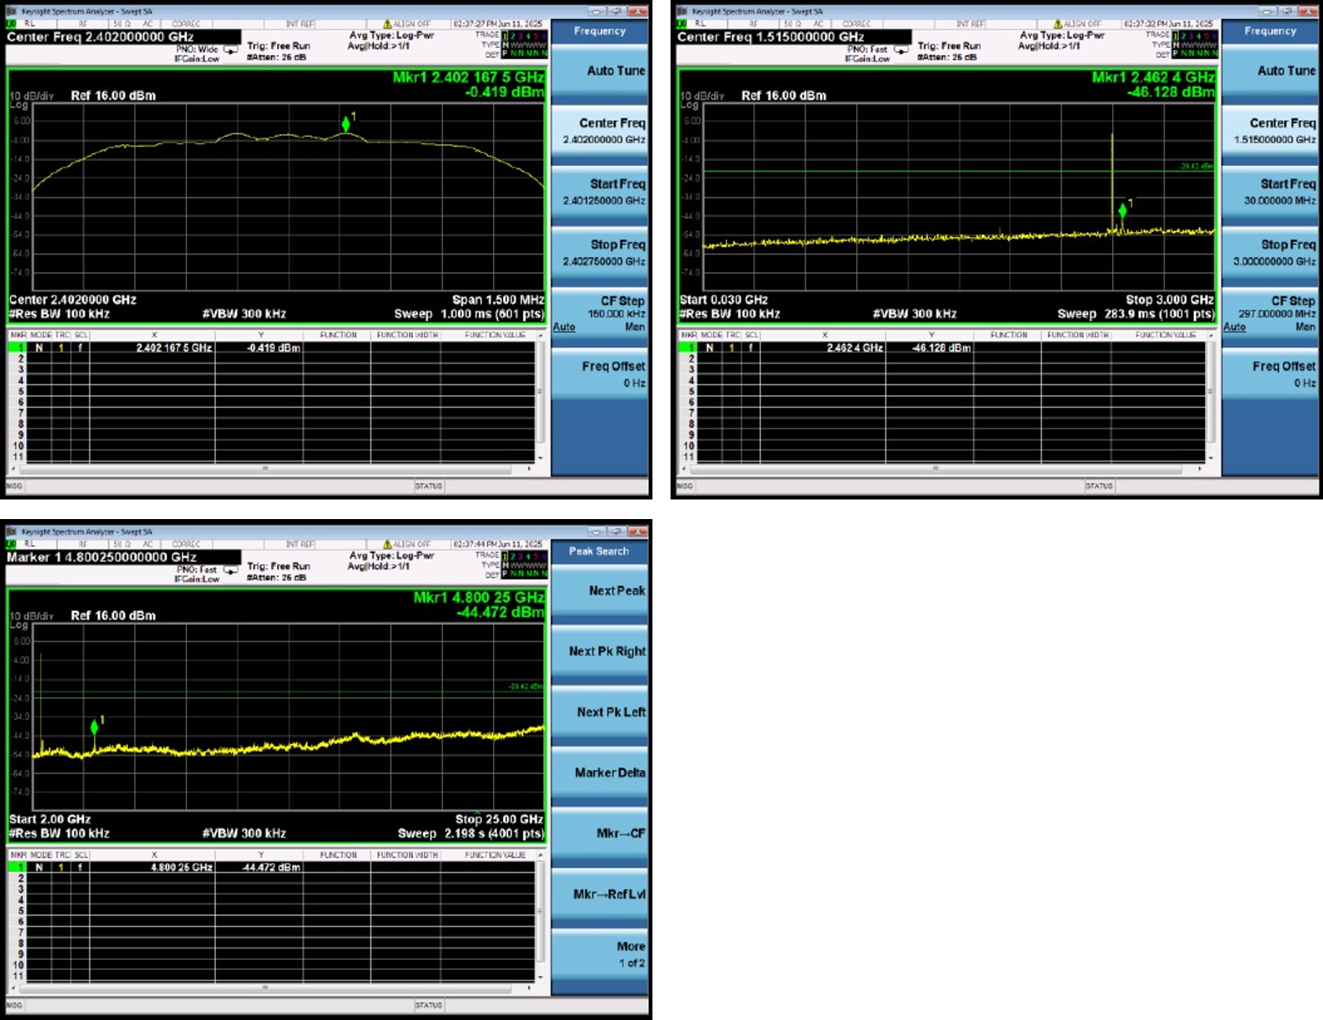

15.3.5. 2DH5 Spurious Measurement Record 5
Upper left: spectrum near the carrier; upper right: lower-frequency spurious emissions; lower left: higher-frequency spurious emissions
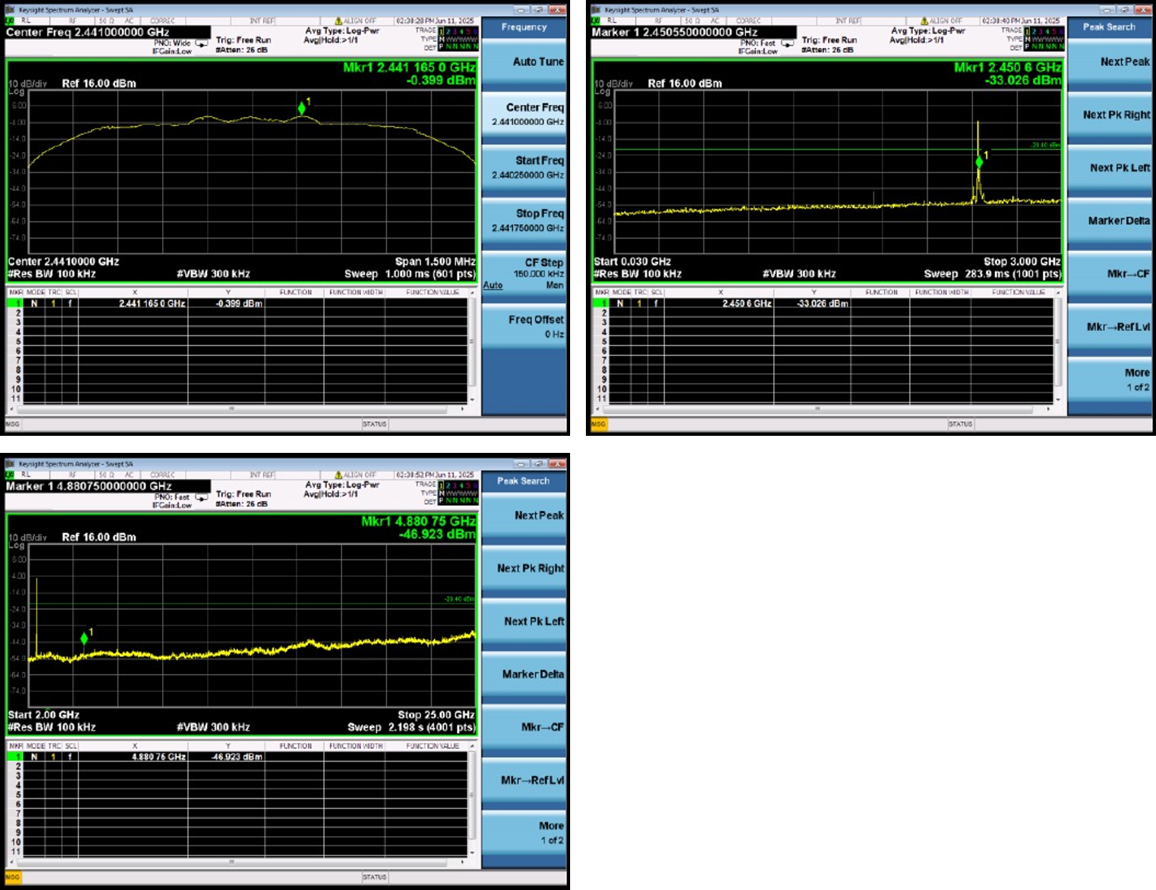

15.3.6. 2DH5 Spurious Measurement Record 6
Upper left: spectrum near the carrier; upper right: lower-frequency spurious emissions; lower left: higher-frequency spurious emissions
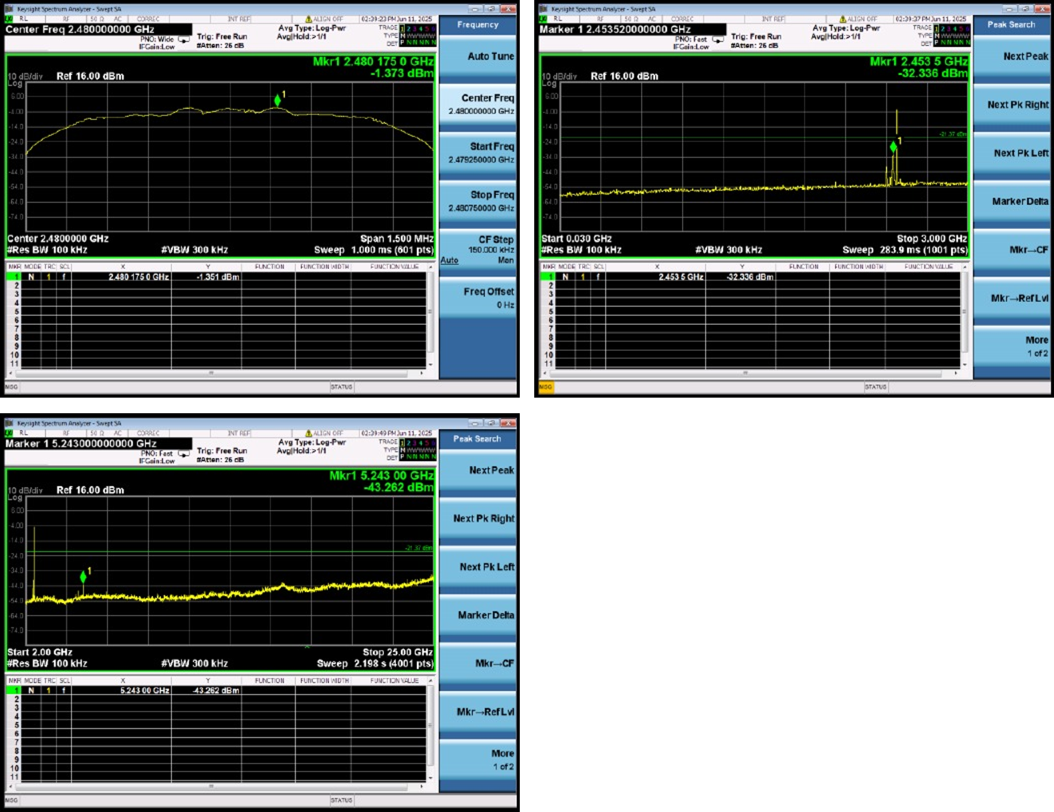

15.3.7. 3DH5 Spurious Measurement Record 7
Upper left: spectrum near the carrier; upper right: lower-frequency spurious emissions; lower left: higher-frequency spurious emissions
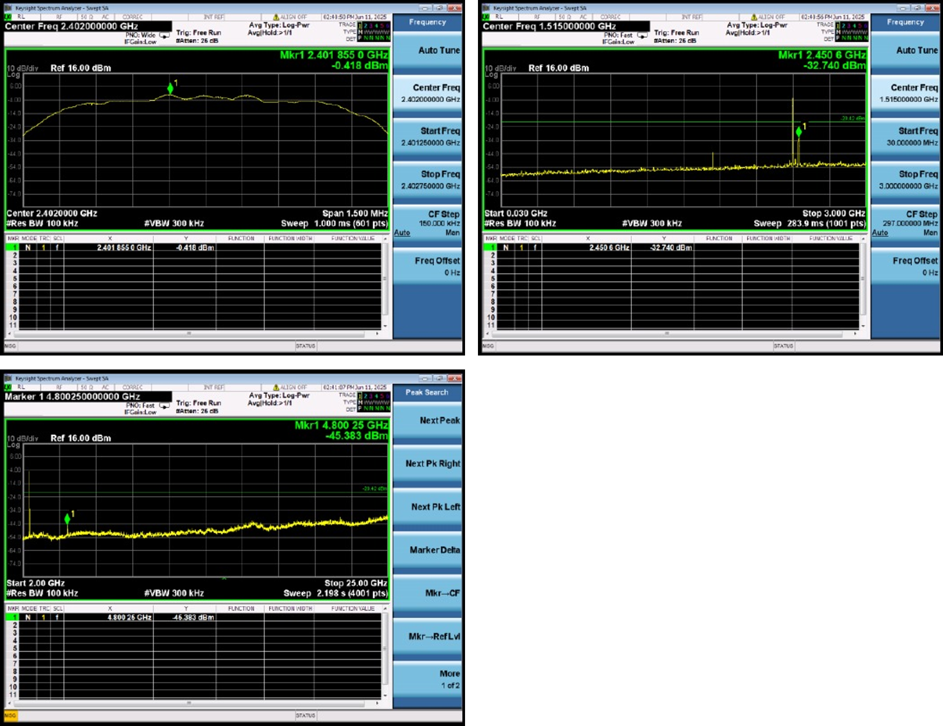

15.3.8. 3DH5 Spurious Measurement Record 8
Upper left: spectrum near the carrier; upper right: lower-frequency spurious emissions; lower left: higher-frequency spurious emissions
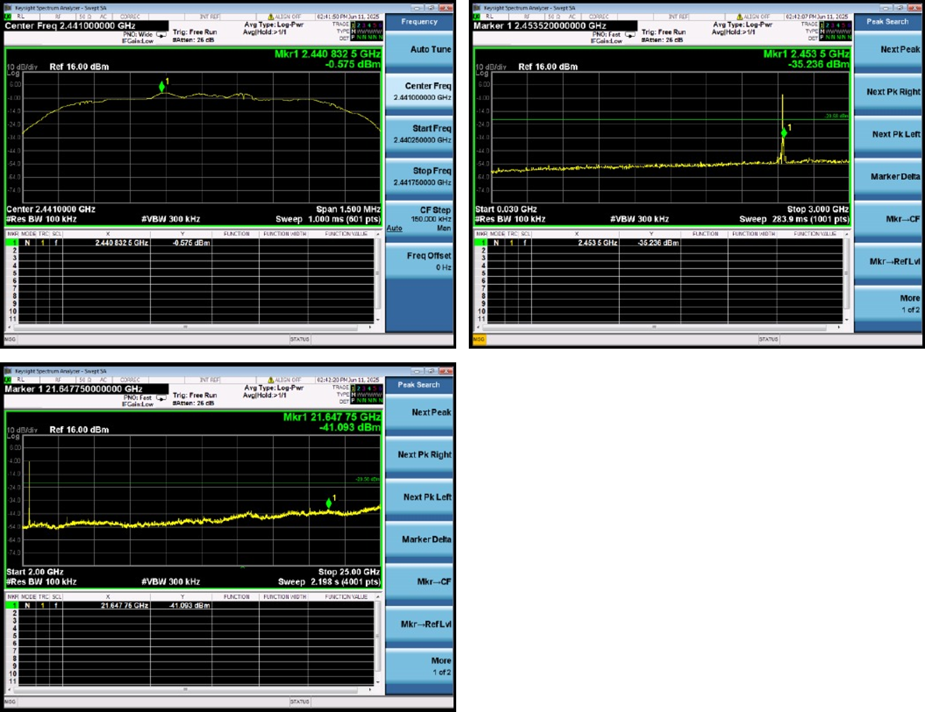

15.3.9. 3DH5 Spurious Measurement Record 9
Upper left: spectrum near the carrier; upper right: lower-frequency spurious emissions; lower left: higher-frequency spurious emissions
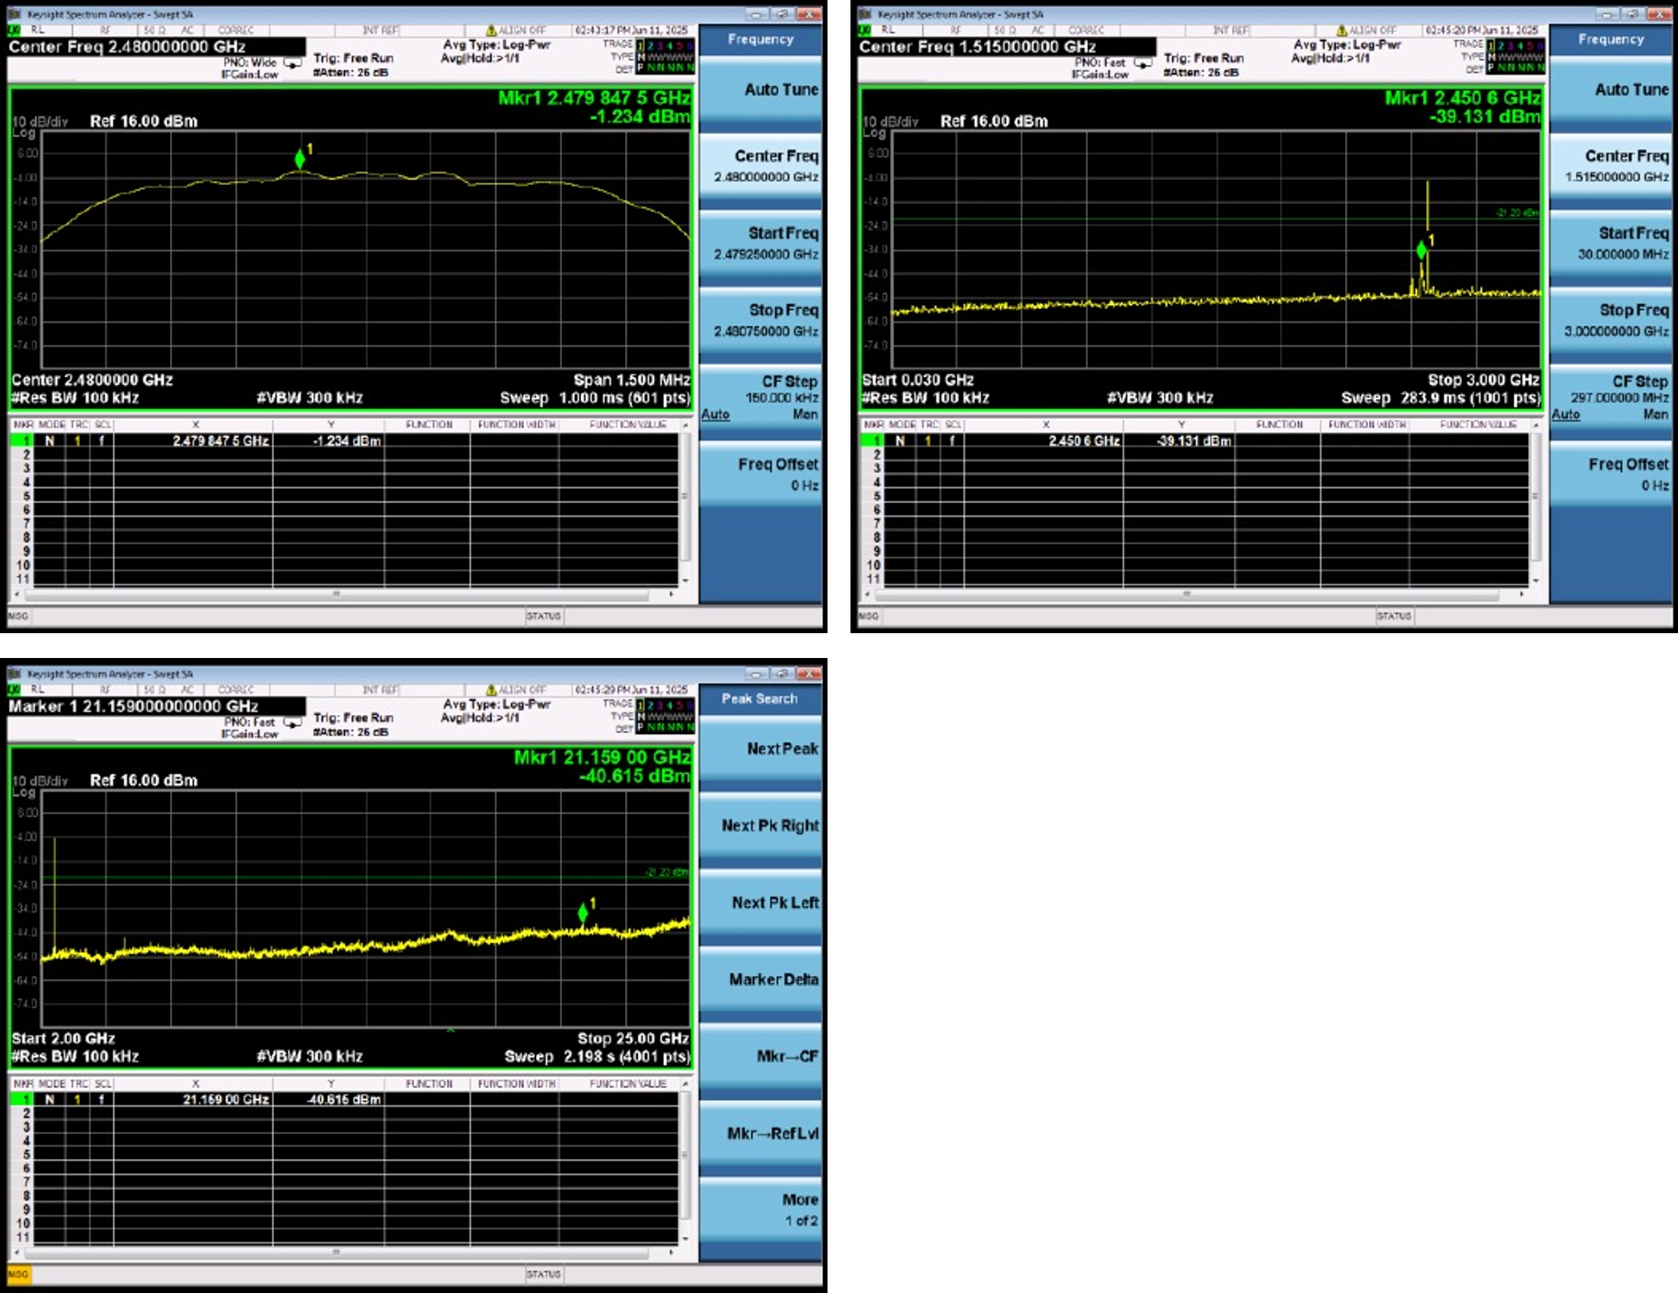

15.4. 99% Occupied Bandwidth and 20 dB Bandwidth
Mode | Center frequency  MHz | Power percentage  % | XdB  Down | RBW  MHz | Detector | Limit  MHz | OBW  MHz | 20 dB bandwidth  MHz | Assessment
DH5 | 2402 | 99.00 | 20 | 0.03 | Peak | 7 | 0.855 | 0.952 | Pass
DH5 | 2441 | 99.00 | 20 | 0.03 | Peak | 7 | 0.848 | 0.956 | Pass
DH5 | 2480 | 99.00 | 20 | 0.03 | Peak | 7 | 0.859 | 0.956 | Pass
2DH5 | 2402 | 99.00 | 20 | 0.03 | Peak | 7 | 1.192 | 1.342 | Pass
2DH5 | 2441 | 99.00 | 20 | 0.03 | Peak | 7 | 1.187 | 1.309 | Pass
2DH5 | 2480 | 99.00 | 20 | 0.03 | Peak | 7 | 1.189 | 1.277 | Pass
3DH5 | 2402 | 99.00 | 20 | 0.03 | Peak | 7 | 1.187 | 1.298 | Pass
3DH5 | 2441 | 99.00 | 20 | 0.03 | Peak | 7 | 1.187 | 1.301 | Pass
3DH5 | 2480 | 99.00 | 20 | 0.03 | Peak | 7 | 1.19 | 1.298 | Pass
The plots show frequency on the horizontal axis and level on the vertical axis, with the main emission spectrum and bandwidth measurement markers; OBW means 99% occupied bandwidth, and XdB Down=20 corresponds to 20 dB bandwidth.
Left: DH5 2402 MHz; right: DH5 2441 MHz
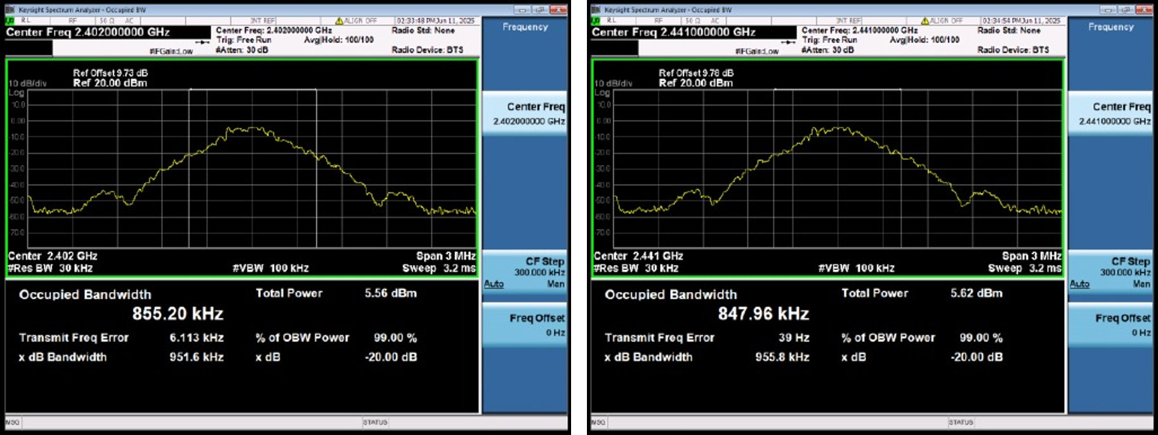
Left: DH5 2480 MHz; right: 2DH5 2402 MHz
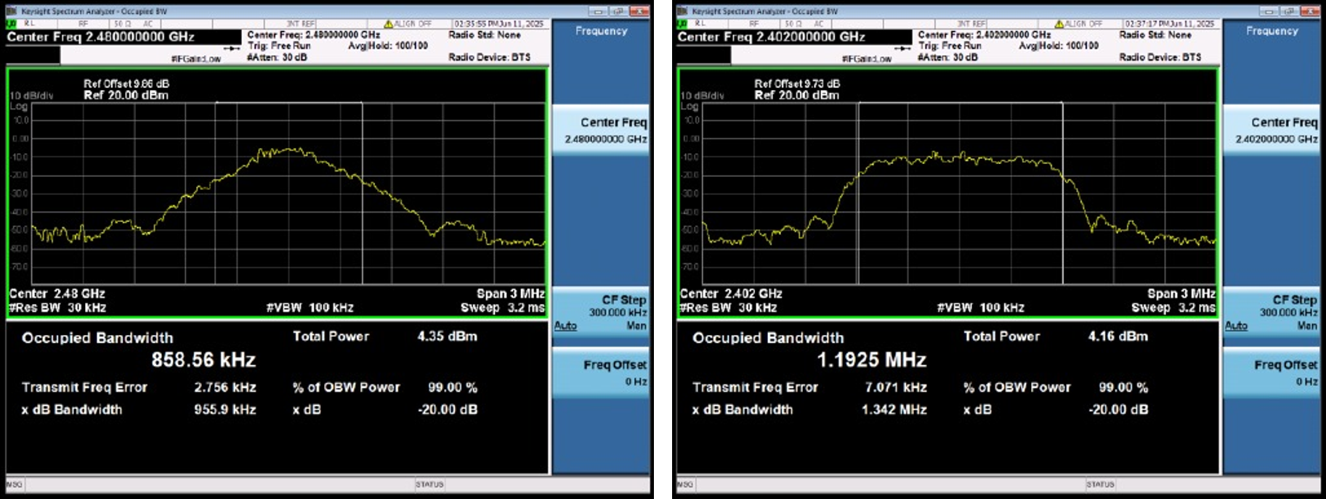
Left: 2DH5 2441 MHz; right: 2DH5 2480 MHz
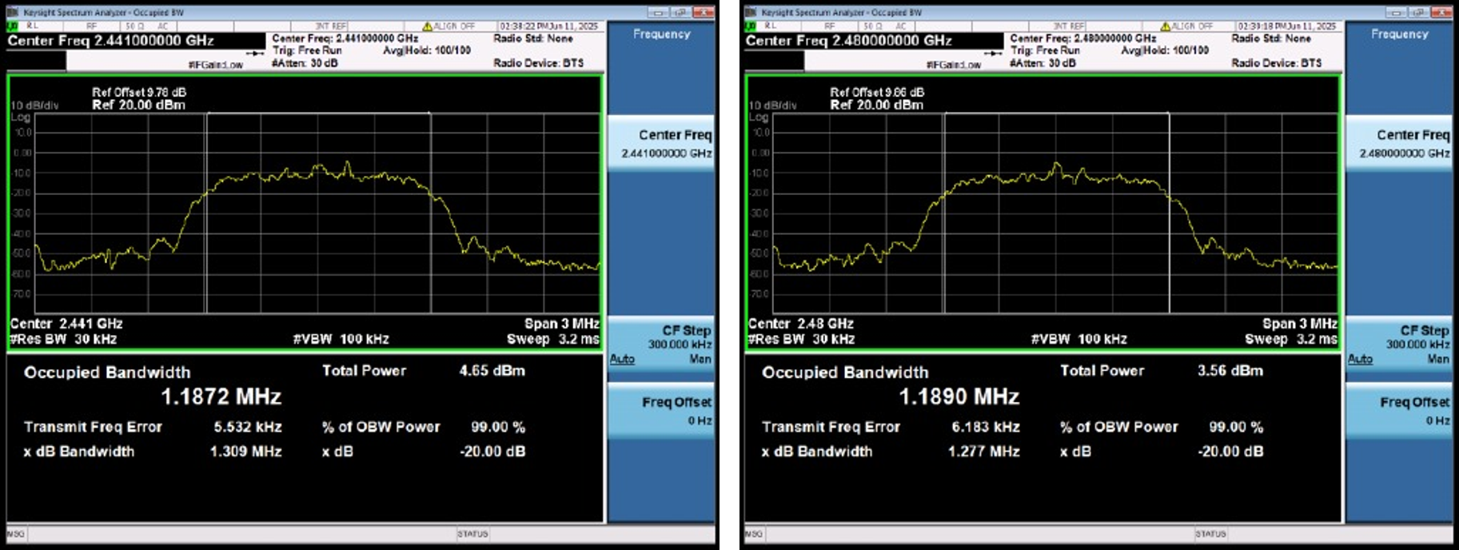
Left: 3DH5 2402 MHz; right: 3DH5 2441 MHz
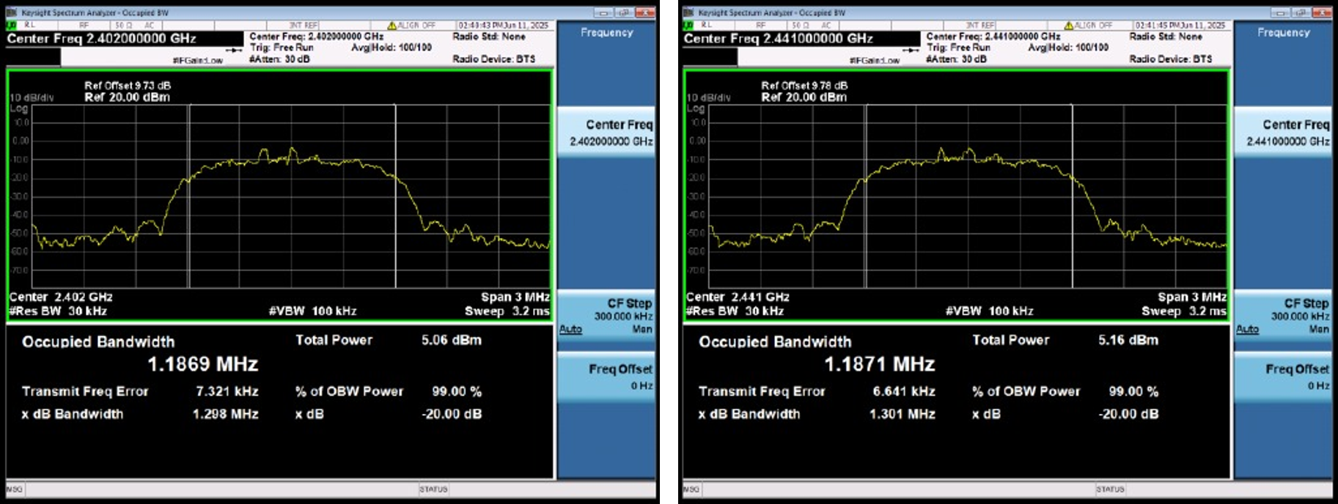
3DH5 2480 MHz
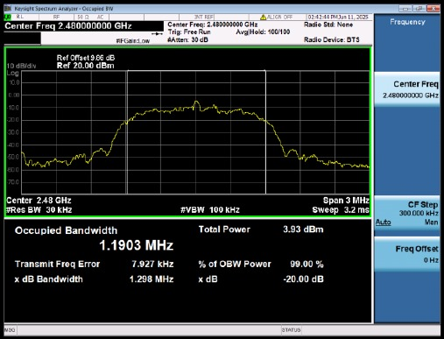

15.5. Hopping Frequency Separation
Center frequency MHz | Mode | HFS MHz | Limit MHz | Assessment
2402 | DH5 | 0.987 | 0.6347 | Pass
2441 | DH5 | 1.013 | 0.6373 | Pass
2480 | DH5 | 1.027 | 0.6373 | Pass
2402 | 2DH5 | 0.923 | 0.8947 | Pass
2441 | 2DH5 | 1.01 | 0.8727 | Pass
2480 | 2DH5 | 0.98 | 0.8513 | Pass
2402 | 3DH5 | 1.003 | 0.8653 | Pass
2441 | 3DH5 | 1.02 | 0.8673 | Pass
2480 | 3DH5 | 0.973 | 0.8653 | Pass
The plots show adjacent hopping carriers and frequency separation measurement markers. For the 2DH5 middle channel, the results table gives a center frequency of 2441 MHz, while the plot title reads “Bluetooth 2DH5 2440MHz.”
Left: DH5 2402 MHz; right: DH5 2441 MHz
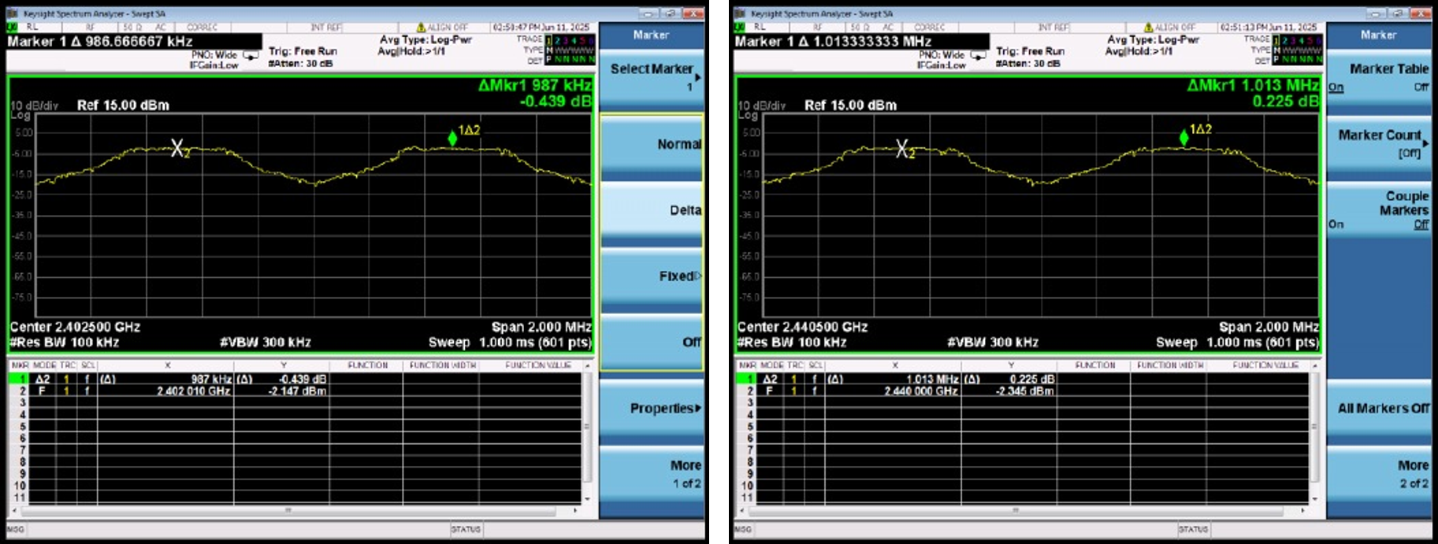
Left: DH5 2480 MHz; right: 2DH5 2402 MHz
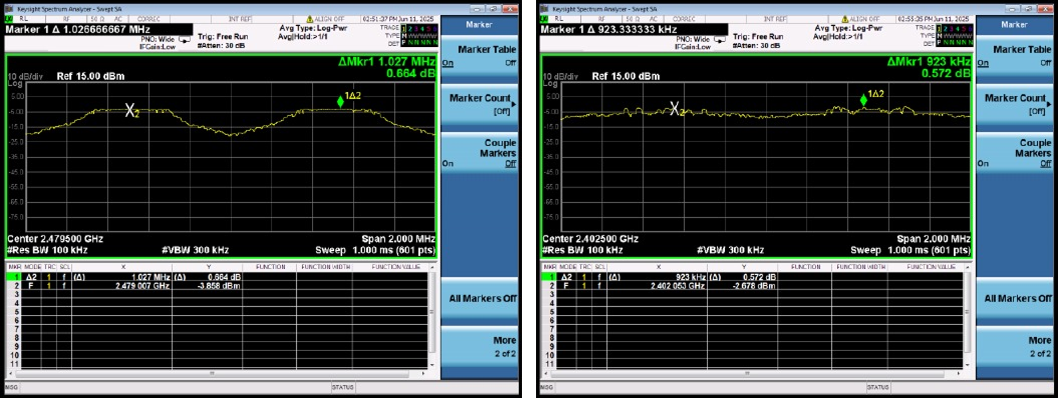
Left: 2DH5 2440 MHz (plot title); right: 2DH5 2480 MHz
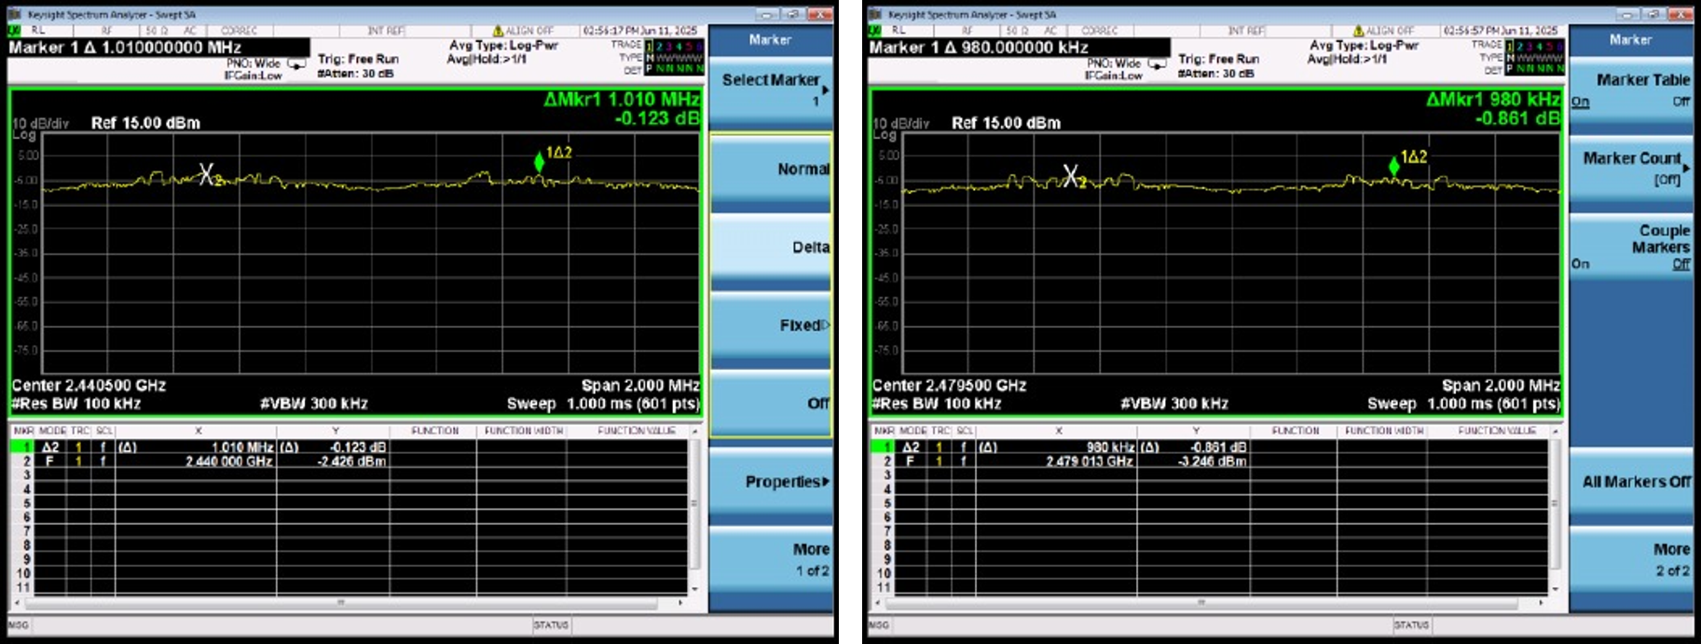
Left: 3DH5 2402 MHz; right: 3DH5 2441 MHz
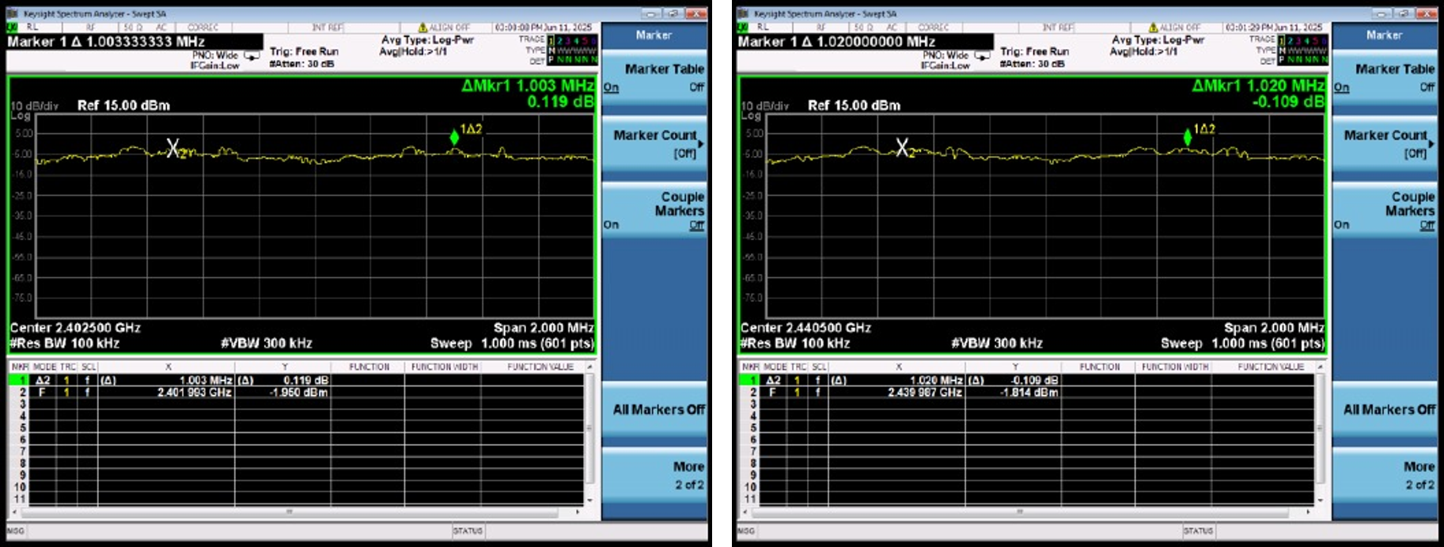
3DH5 2480 MHz
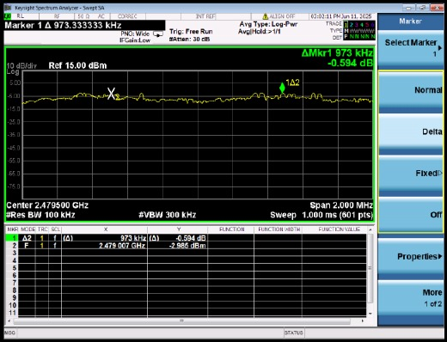

15.6. Average Time of Occupancy
Center frequency MHz | Mode | Pulse duration ms | Dwell time ms | Limit ms | Assessment
2441 | 1-DH5 | 2.880 | 307 | 400 | Pass
2441 | 2-DH5 | 2.880 | 307 | 400 | Pass
2441 | 3-DH5 | 2.880 | 307 | 400 | Pass
The time-domain plots show transmission pulses and pulse-width measurement markers for each mode at 2441 MHz; all pulse durations in the table are 2.880 ms, and all dwell times are 307 ms.
Left: DH5 2441 MHz; right: 2DH5 2441 MHz
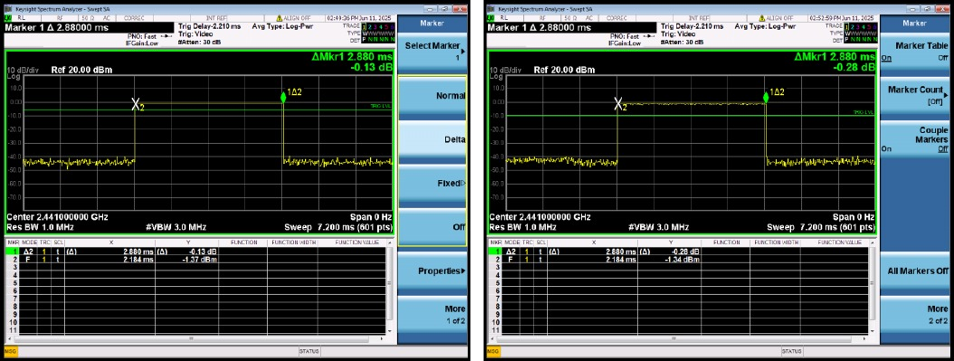
3DH5 2441 MHz
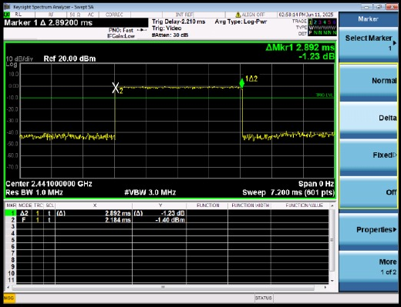

15.7. High-End Band-Edge Conducted Emissions
Bandedge(H)--CSE: DH5, 2DH5, and 3DH5 all use 2480 MHz. Two spectrum views are provided for each mode, showing the carrier near the high-end band edge, the out-of-band spectrum, and measurement markers.
Left: DH5 2480 MHz view 1; right: DH5 2480 MHz view 2
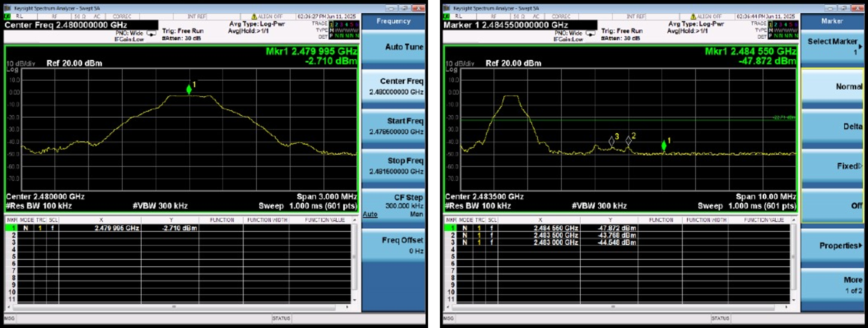
Left: 2DH5 2480 MHz view 1; right: 2DH5 2480 MHz view 2
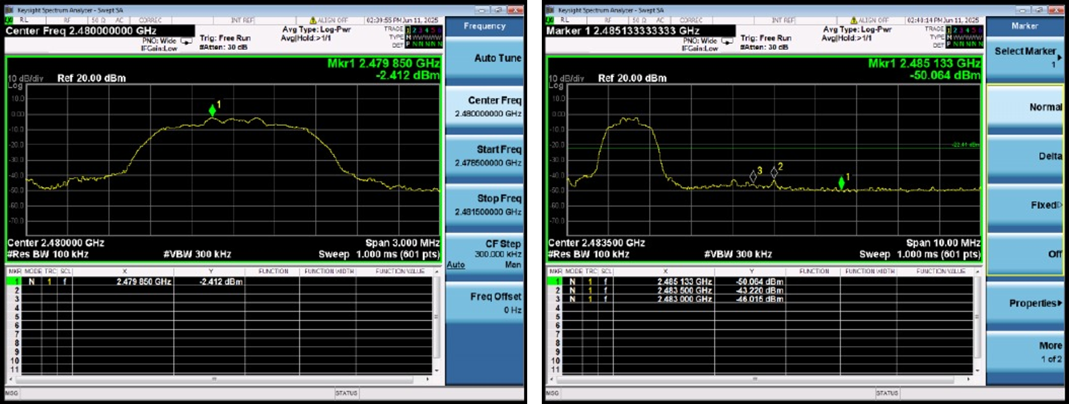
Left: 3DH5 2480 MHz view 1; right: 3DH5 2480 MHz view 2
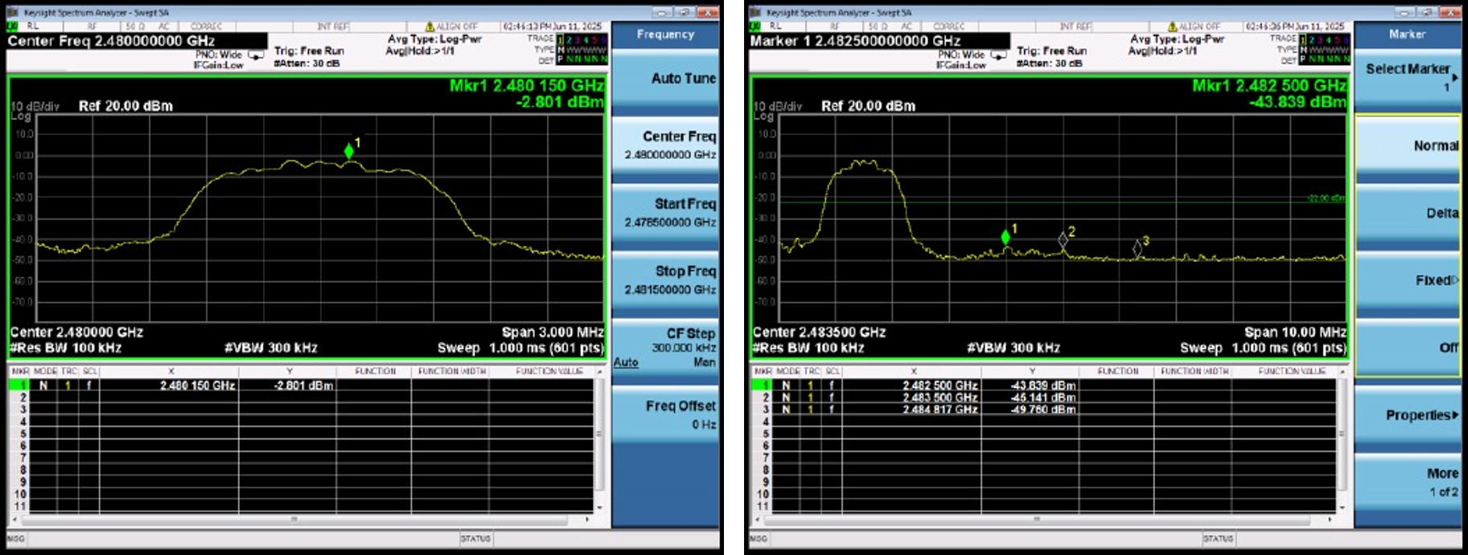

15.8. Hopping Band-Edge Conducted Emissions
Bandedge(hopping)—CSE: Three hopping-state spectra are provided for each of DH5, 2DH5, and 3DH5, showing level distributions and markers for the hopping signal and band-edge scans.
Left: DH5 hopping view 1; right: DH5 hopping view 2
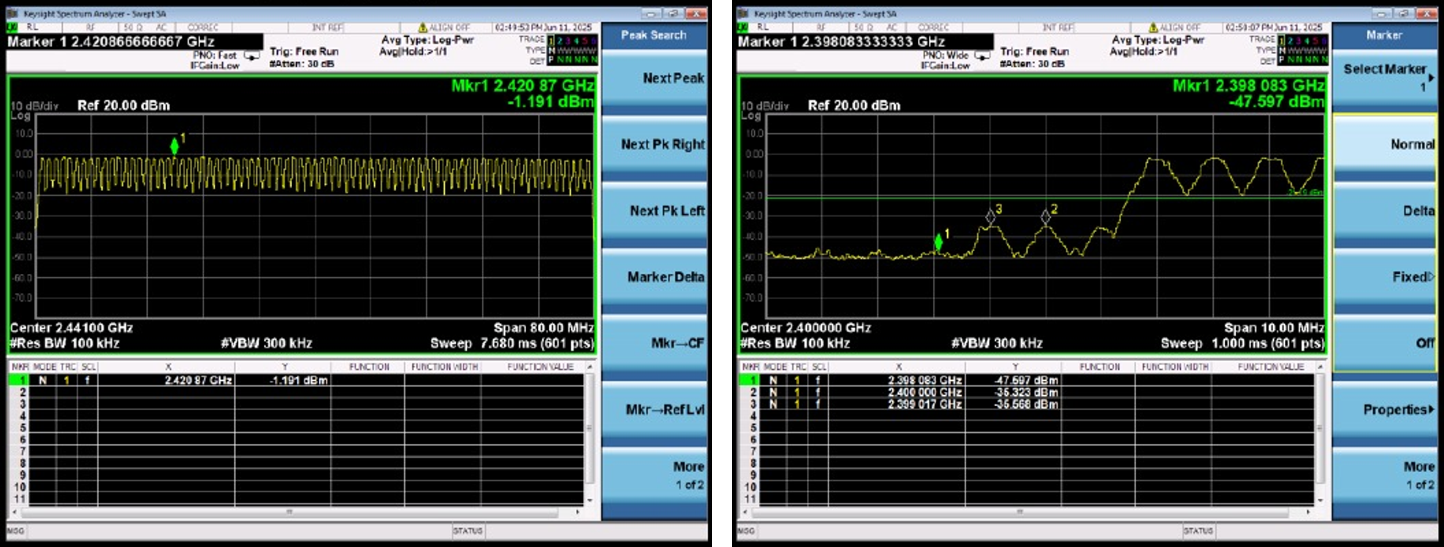
Left: DH5 hopping view 3; right: 2DH5 hopping view 1
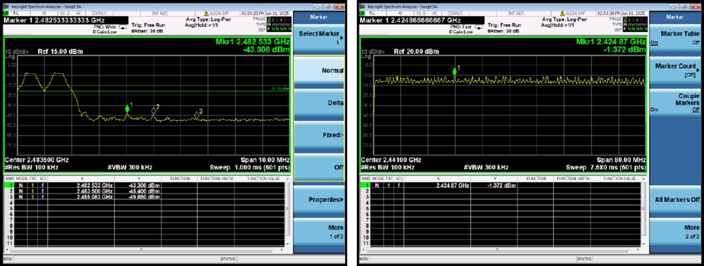
Left: 2DH5 hopping view 2; right: 2DH5 hopping view 3
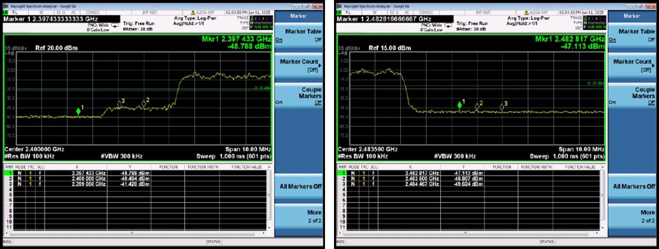
Left: 3DH5 hopping view 1; right: 3DH5 hopping view 2
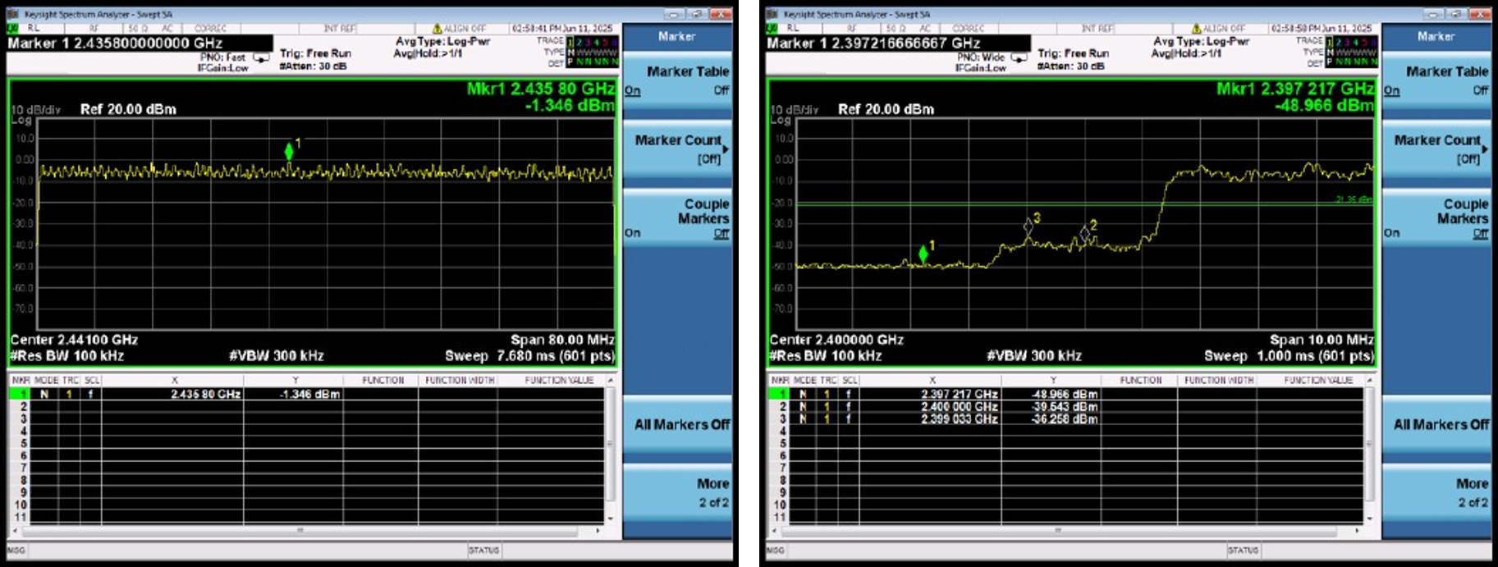
3DH5 Hopping View 3
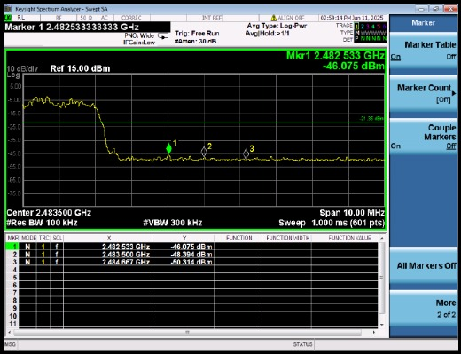

15.9. Low-End Band-Edge Conducted Emissions
Bandedge(L)--CSE: DH5, 2DH5, and 3DH5 all use 2402 MHz. Two spectrum views are provided for each mode, showing the carrier near the low-end band edge, the out-of-band spectrum, and measurement markers.
Left: DH5 2402 MHz view 1; right: DH5 2402 MHz view 2
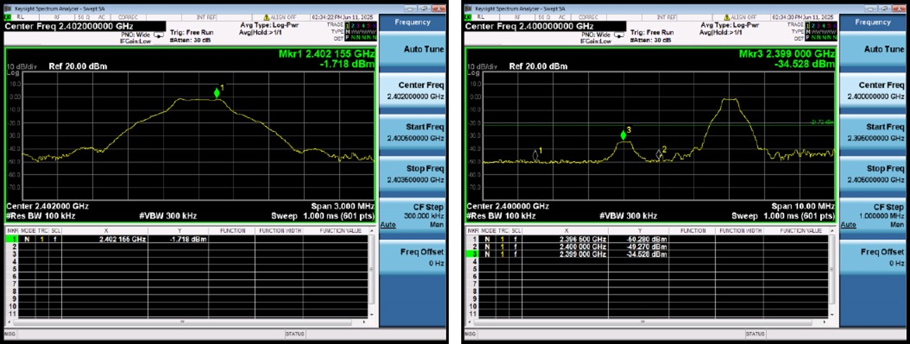
Left: 2DH5 2402 MHz view 1; right: 2DH5 2402 MHz view 2
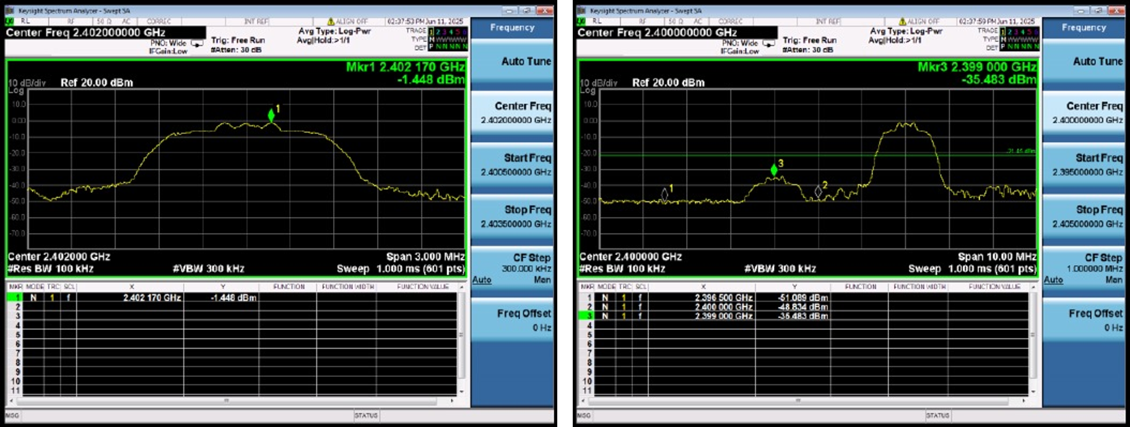
Left: 3DH5 2402 MHz view 1; right: 3DH5 2402 MHz view 2
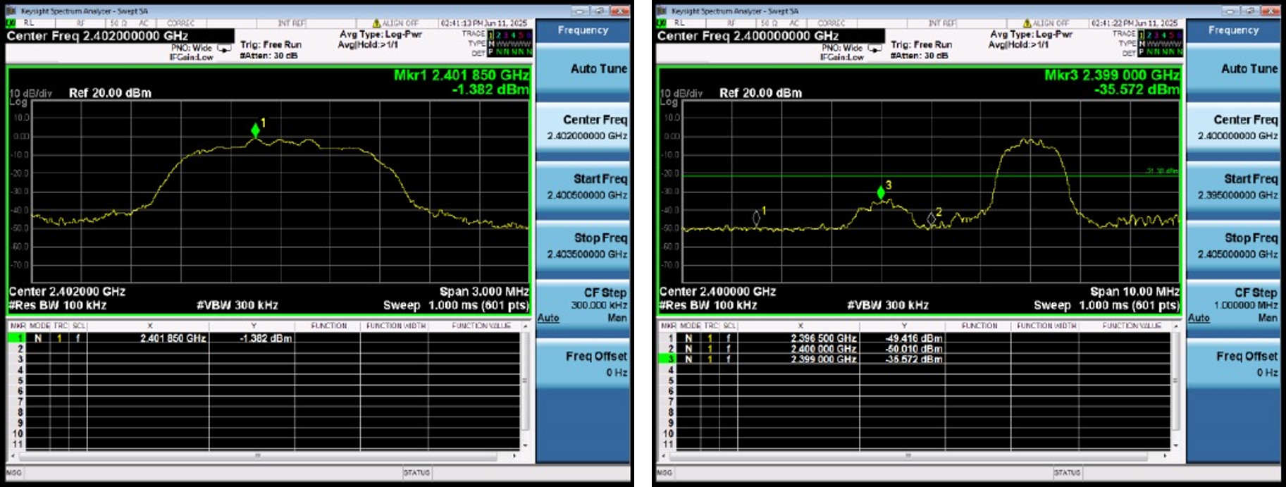

15.10. Duty Cycle
Mode | Center frequency  MHz | RBW  MHz | Detector | Tx On  s | Tx Off  s | Period  s | Duty Cycle | Limit | Assessment
DH5 | 2402 | 8 | RMS | 0.002872 | 0.00088 | 0.003752 | 0.7656 | 0.1 | Pass
DH5 | 2441 | 8 | RMS | 0.00287 | 0.00088 | 0.00375 | 0.7653 | 0.1 | Pass
DH5 | 2480 | 8 | RMS | 0.00287 | 0.00088 | 0.00375 | 0.7653 | 0.1 | Pass
2DH5 | 2402 | 8 | RMS | 0.00288 | 0.00087 | 0.00375 | 0.768 | 0.1 | Pass
2DH5 | 2441 | 8 | RMS | 0.00288 | 0.00087 | 0.00375 | 0.768 | 0.1 | Pass
2DH5 | 2480 | 8 | RMS | 0.00289 | 0.00086 | 0.00375 | 0.7707 | 0.1 | Pass
3DH5 | 2402 | 8 | RMS | 0.002877 | 0.000868 | 0.003745 | 0.7683 | 0.1 | Pass
3DH5 | 2441 | 8 | RMS | 0.00288 | 0.00087 | 0.00375 | 0.768 | 0.1 | Pass
3DH5 | 2480 | 8 | RMS | 0.002884 | 0.000868 | 0.003752 | 0.7685 | 0.1 | Pass
The time-domain plots show transmit-on, transmit-off, and period measurement markers for each mode and frequency; Tx On, Tx Off, and Period are in seconds, and duty cycles are recorded as decimals.
Left: DH5 2402 MHz; right: DH5 2441 MHz
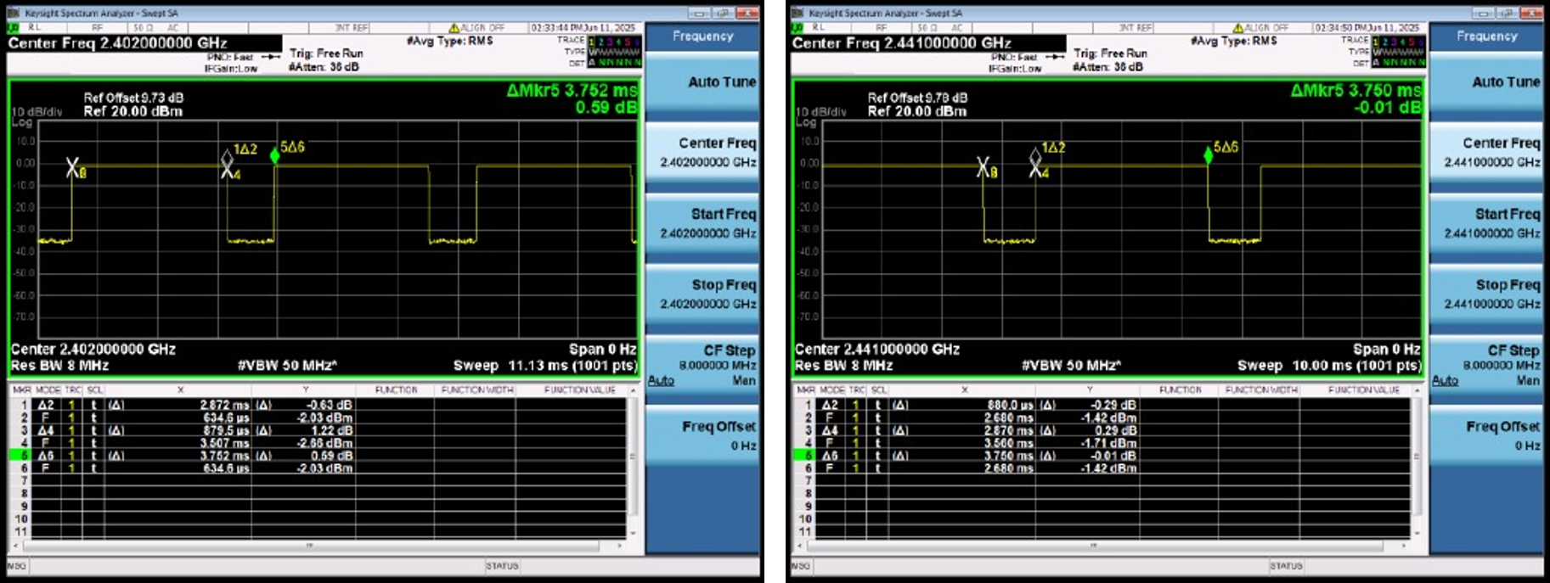
Left: DH5 2480 MHz; right: 2DH5 2402 MHz
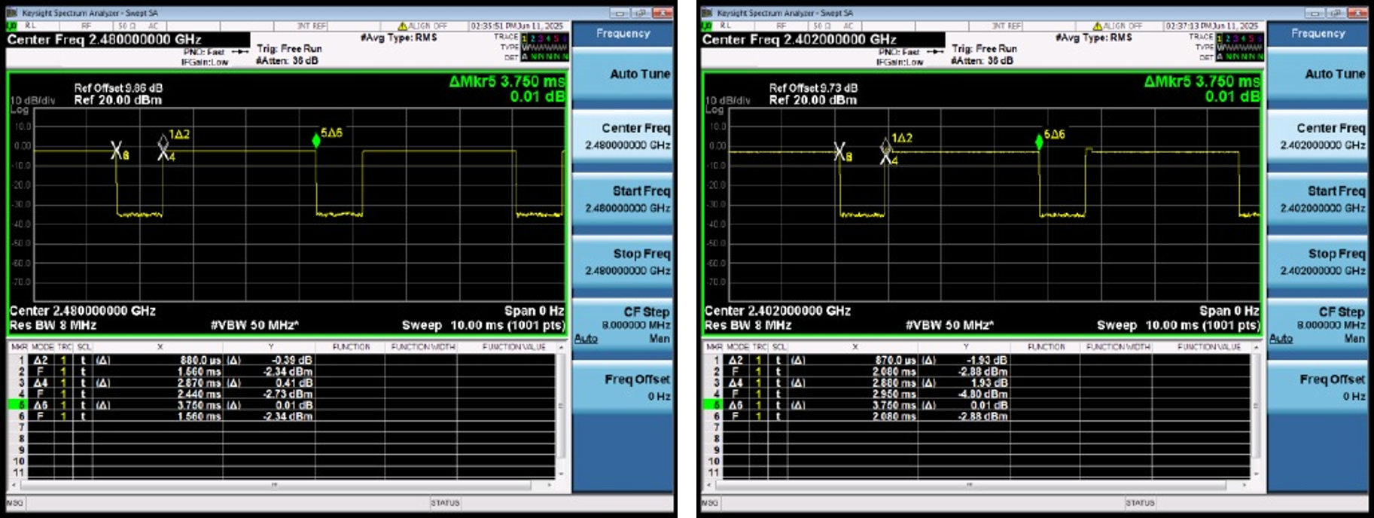
Left: 2DH5 2441 MHz; right: 2DH5 2480 MHz
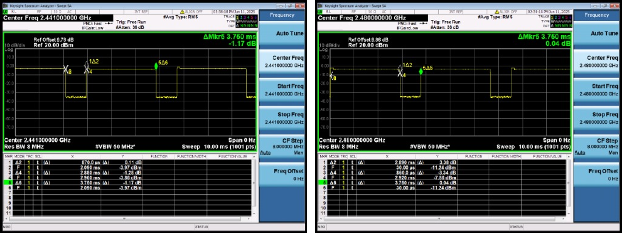
Left: 3DH5 2402 MHz; right: 3DH5 2441 MHz
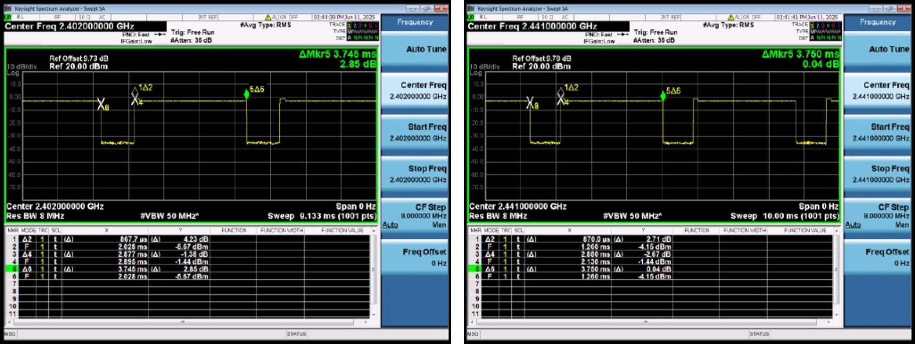
3DH5 2480 MHz
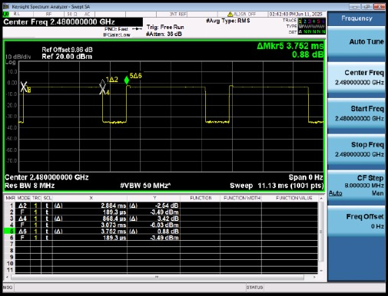

16. Measurement Photo Notes
Test setup photo attachment: RF_Test Setup photos for FCC ID & IC.
Please see the attached RF_Test Setup photos for FCC ID & IC.

17. Original Report Images
